INDEX

Sr No | Index | Date | Page No.
1 | To build, train, evaluate, and save a Machine Learning model using Python for predicting telecom tower hardware failures.
2 | To install Git on the local system, create a GitHub repository, and upload the MLOps project for version control.
3 | To perform load testing on a Machine Learning API that predicts telecom tower hardware failures and analyze its performance under multiple concurrent users.
4 | To Implement Basic File handling , Process and Job management , System monitoring , Linux Commands .
5 | To monitor the performance of a trained machine learning model on new production data and identify model/data drift using MLflow and Evidently
6 | Configuring the CI/CD Pipeline for Telecom Tower Failure Prediction using AWS CodePipeline
7 | To create an Amazon S3 bucket for storing datasets and trained machine learning models.
8 | To create and execute a serverless workflow using Google Cloud Workflows without managing any physical or virtual servers

Practical 1 - Building and Training a Machine Learning Model for Telecom Tower Failure Prediction
Aim : To build, train, evaluate, and save a Machine Learning model using Python for predicting telecom tower hardware failures.
Software Required
- Python 3.11 or above
- Python IDLE (or VS Code)
- Internet Connection
- Command Prompt
Required Python Libraries
Open Command Prompt and install the following packages.
pip install pandas
pip install scikit-learn
pip install joblib

Expected Output
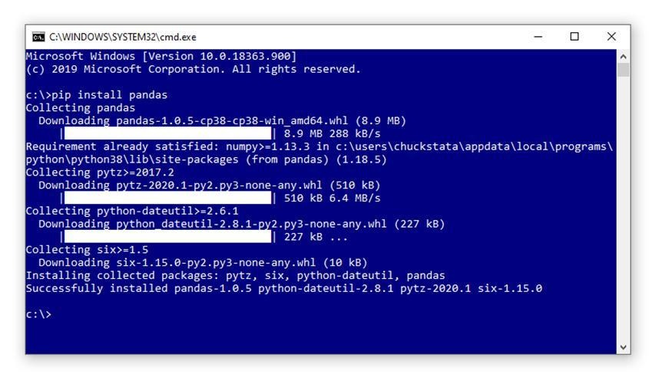
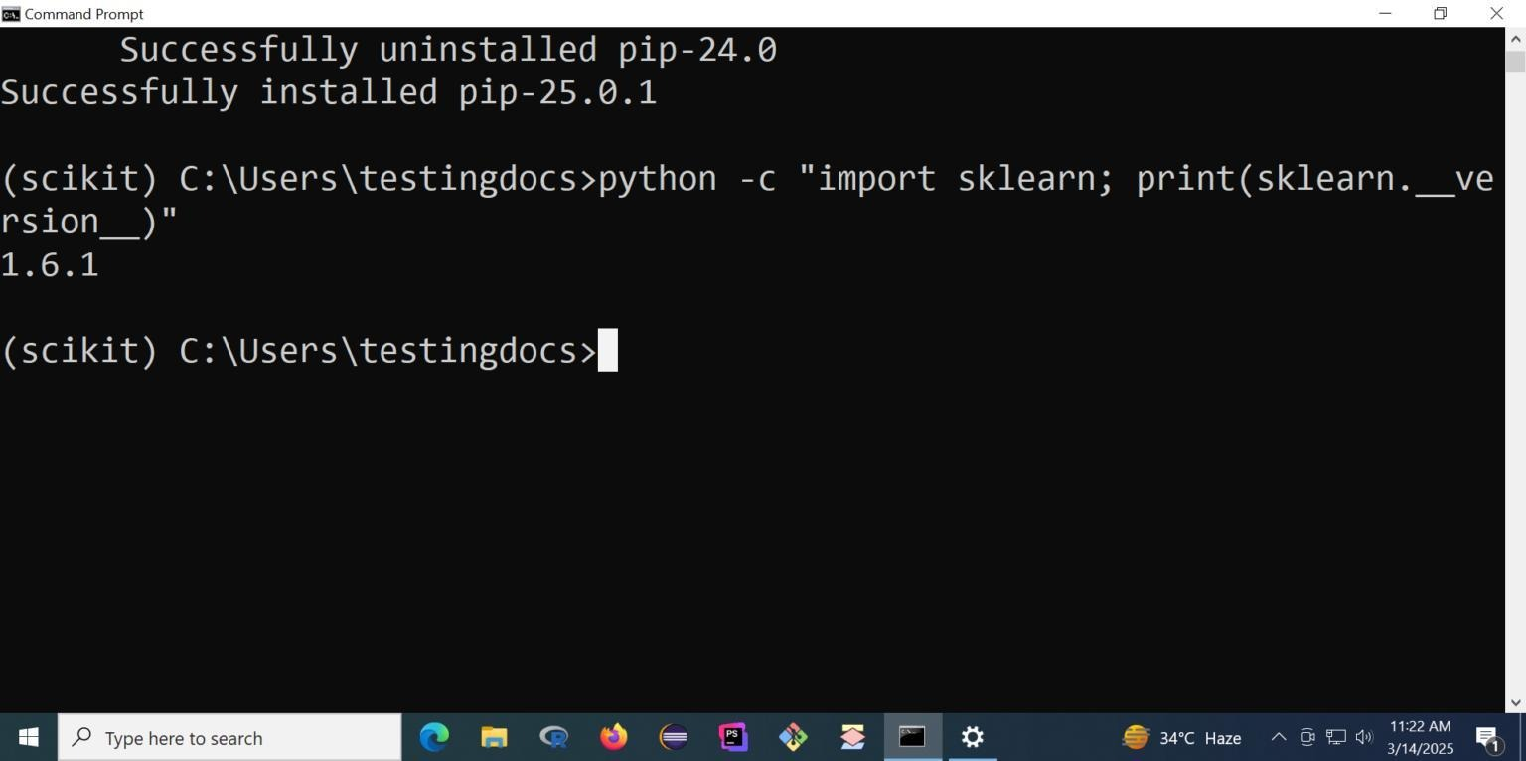
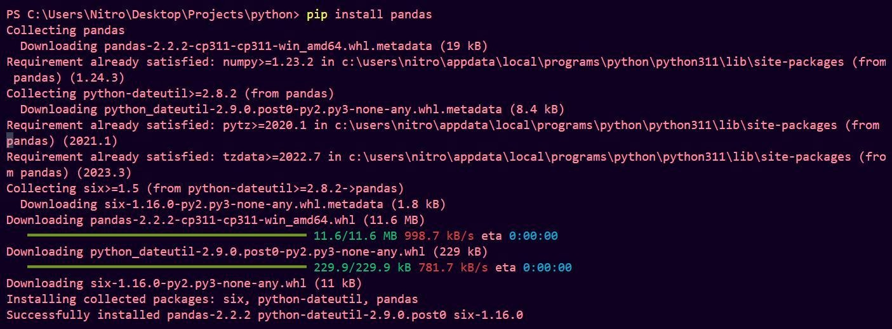
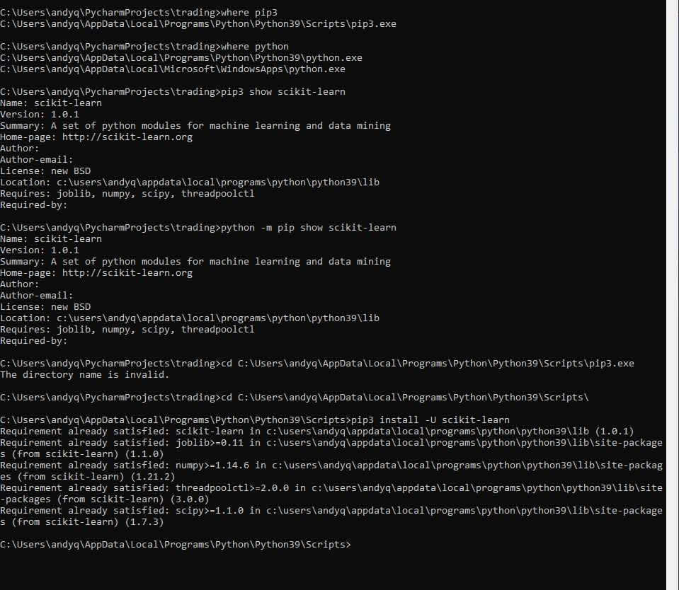

Students should see
Successfully installed...

Step 1
Create Project Folder
Create the following folder.
Desktop > MLOPS > mlops prac > prac_1

Inside prac1 paste
tower_telemetry.csv

Step 2
Create Python File
Open Python IDLE
New File
Save as train.py Inside prac_1

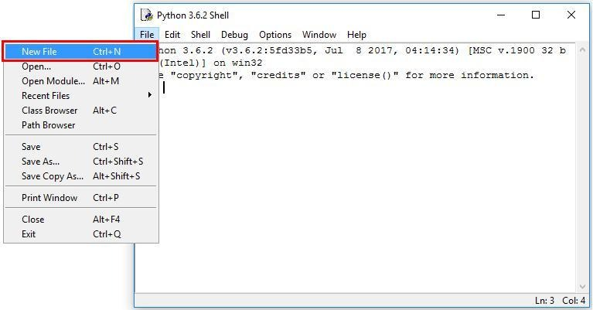
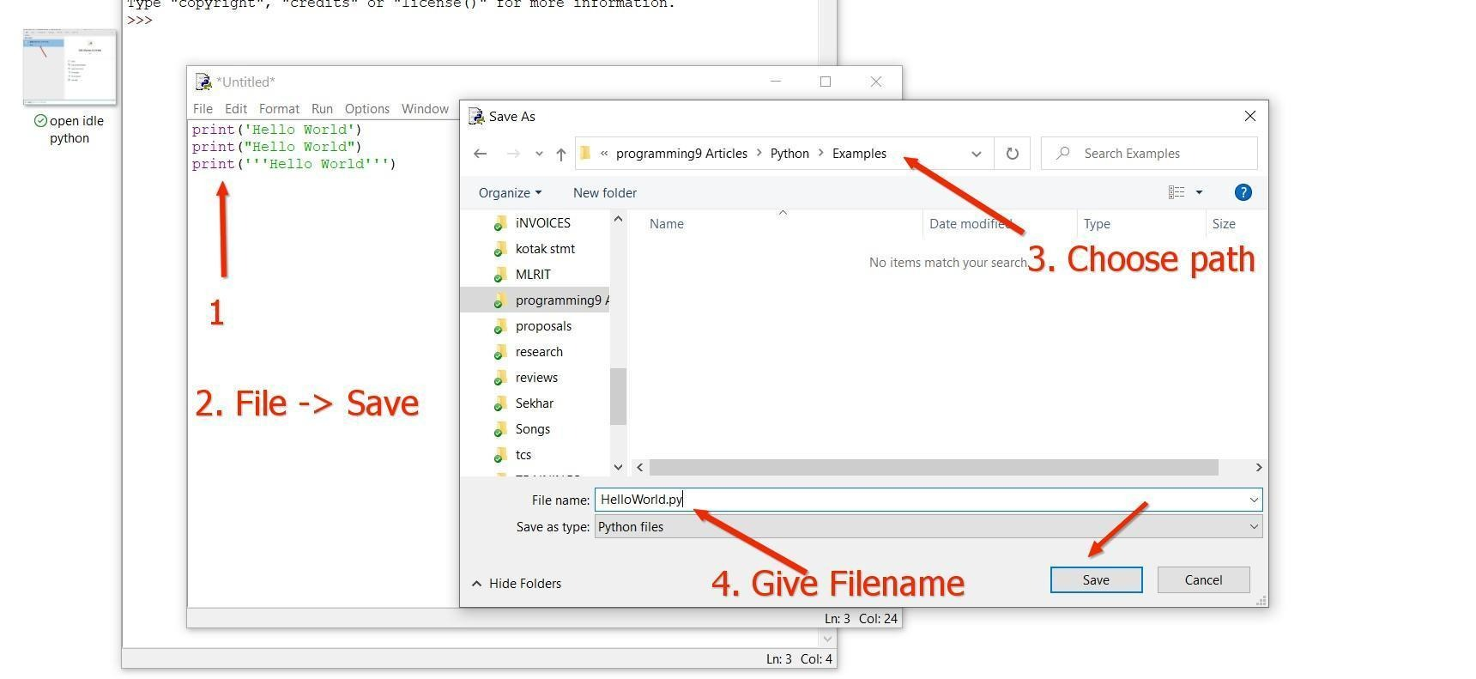
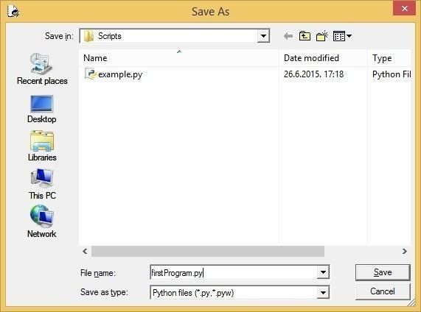
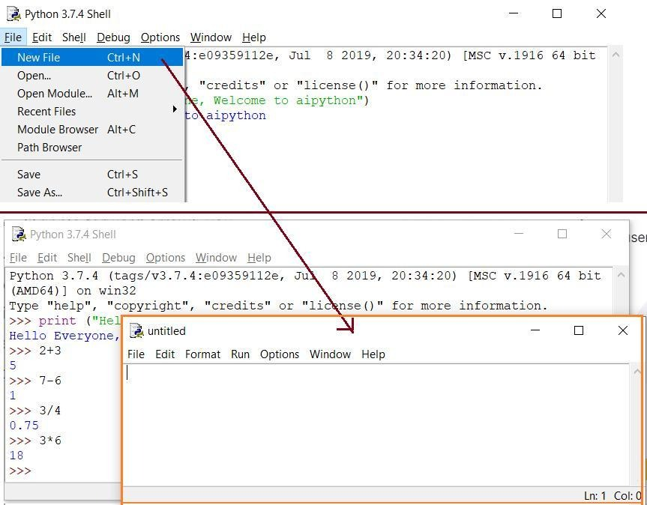
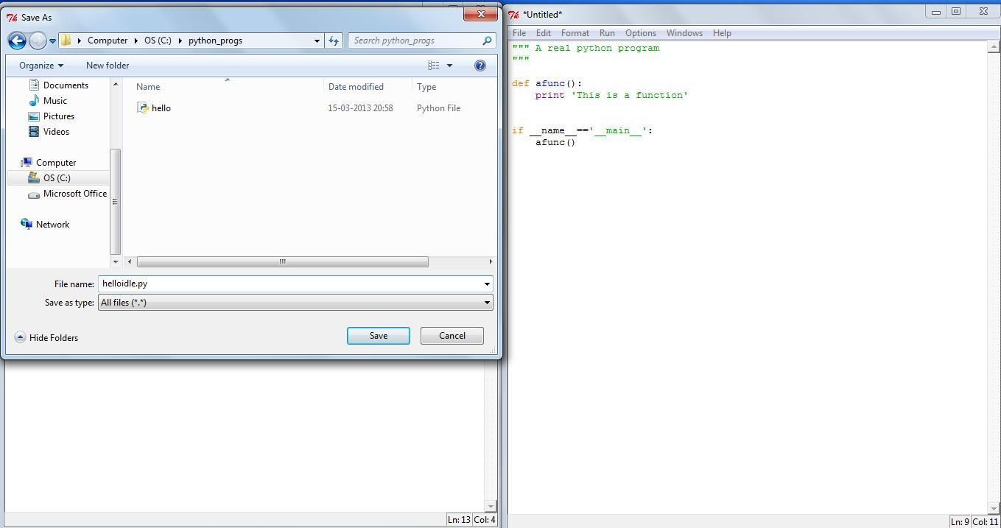
Step 3
Write Python Program
Paste the following program.
import pandas as pd
from sklearn.model_selection import train_test_split
from sklearn.ensemble import RandomForestClassifier
import joblib
import json

print("Loading Dataset...")
df = pd.read_csv("tower_telemetry.csv")
X = df[['voltage',
'temperature_c',
'signal_drop_rate',
'cpu_usage',
'battery_health',
'network_latency_ms']]
y = df['hardware_failure']
X_train,X_test,y_train,y_test = train_test_split(
X,
y,
test_size=0.25,
random_state=42
)
print("Training Model...")
model=RandomForestClassifier(
n_estimators=100,
random_state=42
)
model.fit(X_train,y_train)
accuracy=model.score(X_test,y_test)
print("Accuracy :",accuracy)
joblib.dump(model,"telecom_tower_model.pkl")
metrics={"accuracy":accuracy}
with open("metrics.json","w") as f:
json.dump(metrics,f,indent=4)
print("Training Completed Successfully")

Save the file.
Step 5
Run the Program
Open Command Prompt.
Go to your folder.
cd "C:\Users\sarve\Desktop\MLOPS\mlops prac\prac_1"
Run
python train.py

Expected Output
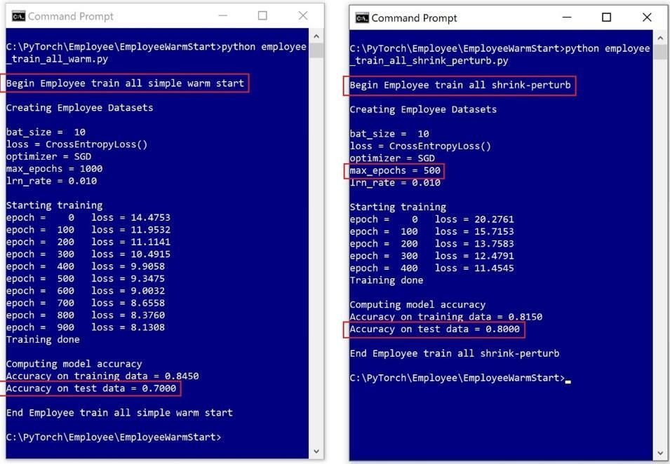

Students should see something similar to
Loading Dataset...
Training Model...
Accuracy : 1.0
Training Completed Successfully

Step 6
Check Generated Files
What are these files?
File | Purpose
tower_telemetry.csv | Training Dataset
train.py | ML Training Script
telecom_tower_model.pkl | Trained Machine Learning Model
metrics.json | Model Accuracy Report

Step 7
Create Prediction Program
Create another file
predict.py

import joblib
import pandas as pd
model=joblib.load("telecom_tower_model.pkl")
new_data=pd.DataFrame({
"voltage":[11.2],
"temperature_c":[55],
"signal_drop_rate":[0.5],
"cpu_usage":[88],
"battery_health":[65],
"network_latency_ms":[95]
})

prediction=model.predict(new_data)

if prediction[0]==1:

print("Hardware Failure Predicted")

else:

print("Tower is Healthy")

Save.

Step 8
Run Prediction
python predict.py

Expected Output
Hardware Failure Predicted
or
Tower is Healthy
depending on the prediction.

MLOps Cloud Engineering Lab – Practical 3
Step 9: Create an Amazon S3 Bucket

Practical 2 - Installing Git and Uploading Your MLOps Project to GitHub
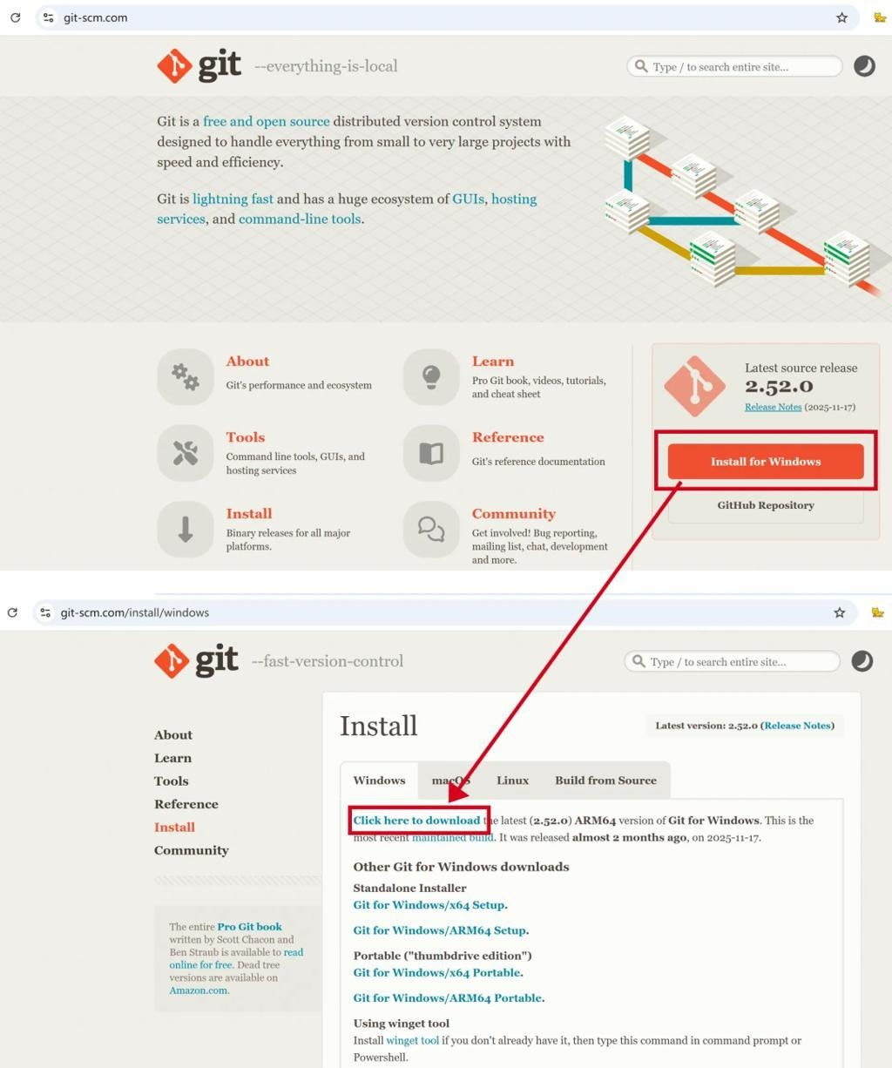
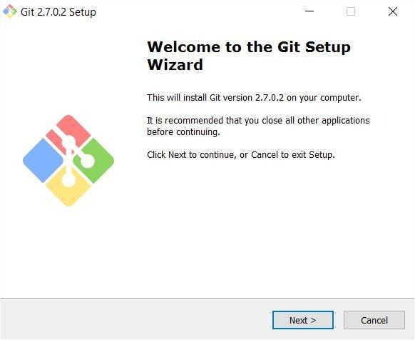
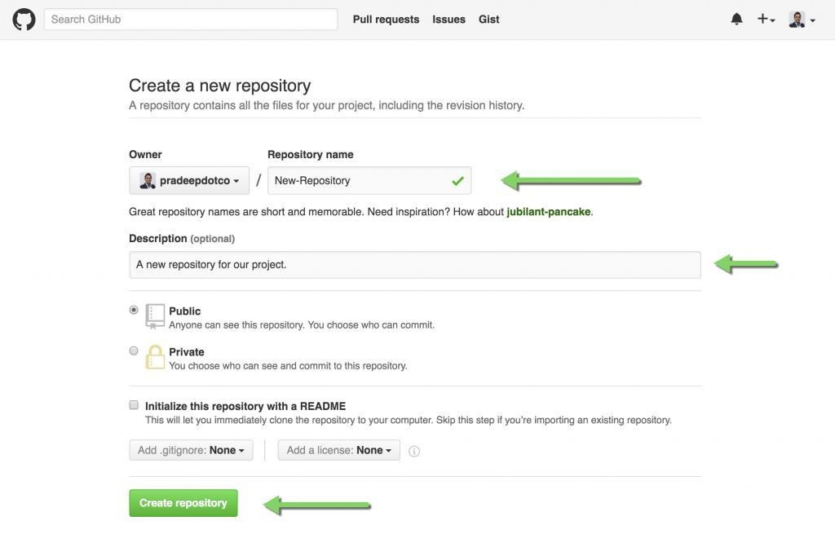

Aim : To install Git on the local system, create a GitHub repository, and upload the MLOps project for version control.

Step 1: Download Git
Open your browser and visit:
Git Downloads
Click Download for Windows.

Step 2: Install Git
- Double-click the downloaded installer.
- Click Next for all installation screens (keep the default settings).
- Click Install.
- Click Finish.

Step 3: Verify Installation
Open Command Prompt.
Type:
git --version
If Git is installed correctly, you will see something similar to:
git version 2.49.0

Step 4: Create a GitHub Account
Go to:
GitHub
Click Sign Up.
Complete:
- Email Address
- Password
- Username
Verify your email.

Step 5: Create a New Repository
After logging in:
- Click the + icon (top-right).
- Select New repository.
Fill in:
Field | Value
Repository Name | Telecom-MLops
Description | MLOps Practical
Visibility | Public (or Private if preferred)
Initialize README | Leave unchecked
Click Create Repository.

Step 6: Open Your Project Folder
Suppose your project is located at:
C:\Users\sarve\Desktop\MLOPS\mlops prac\prac_1
Open Command Prompt.
Navigate to the folder:
cd "C:\Users\sarve\Desktop\MLOPS\mlops prac\prac_1"

Step 7: Initialize Git
Type:
git init
Output:
Initialized empty Git repository
A hidden .git folder is created to track all changes.

Step 8: Configure Git (First Time Only)
Replace with your own name and GitHub email:
git config --global user.name "Your Name"
git config --global user.email "your_email@gmail.com"
Verify:
git config --list

Step 9: Check Project Status
Type:
git status
Output:
Untracked files:

train.py
app.py
tower_telemetry.csv
metrics.json
telecom_tower_model.pkl
These files are not yet being tracked.

Step 10: Add All Files
Type:
git add .
Now check:
git status
You should see:
Changes to be committed

Step 11: Commit Files
Type:
git commit -m "Initial MLOps Project"
Example output:
[master] Initial MLOps Project
5 files changed
Git has now created the first version (commit) of your project.

Step 12: Copy the Repository URL
On your GitHub repository page, click the green Code button.
Copy the HTTPS URL.
Example:
https://github.com/yourusername/Telecom-MLops.git

Step 13: Connect Local Project to GitHub
In Command Prompt:
git remote add origin https://github.com/yourusername/Telecom-MLops.git
Verify:
git remote -v

Step 14: Push Your Project
If your default branch is main:
git branch -M main
Now push:
git push -u origin main
GitHub may ask you to authenticate.
After a successful push, you'll see output similar to:
Branch 'main' set up to track 'origin/main'

Step 15: Refresh GitHub
Open your repository in the browser.
You should now see:
Telecom-MLops

├── app.py
├── train.py
├── tower_telemetry.csv
├── telecom_tower_model.pkl
├── metrics.json
└── README.md (if added later)

Step 16: Make a Change
Open train.py.
Add:
print("Training Started...")
Save the file.

Step 17: Upload the New Version
Run the following commands:
git add train.py
git commit -m "Updated training message"
git push
Refresh GitHub.
The updated version of train.py is now stored in the repository.

Git Workflow
Create Project
│
▼
git init
│
▼
git add .
│
▼
git commit
│
▼
git push
│
▼
GitHub Repository

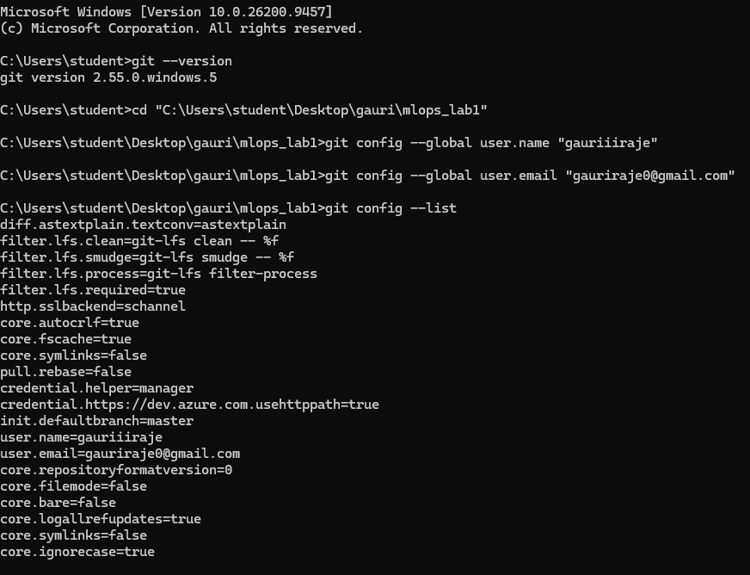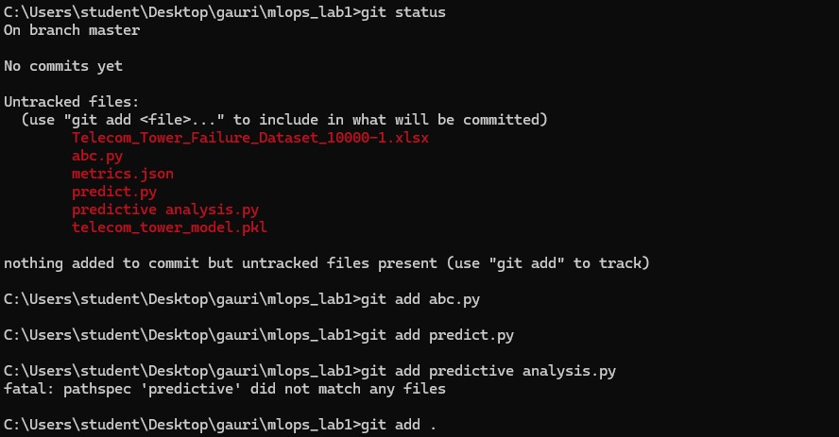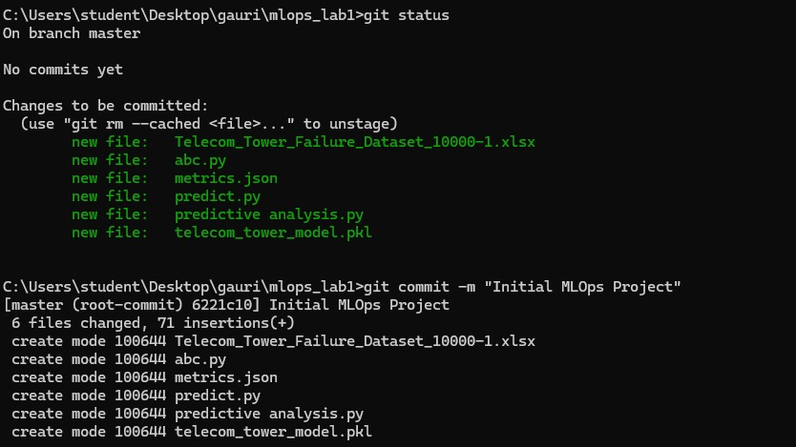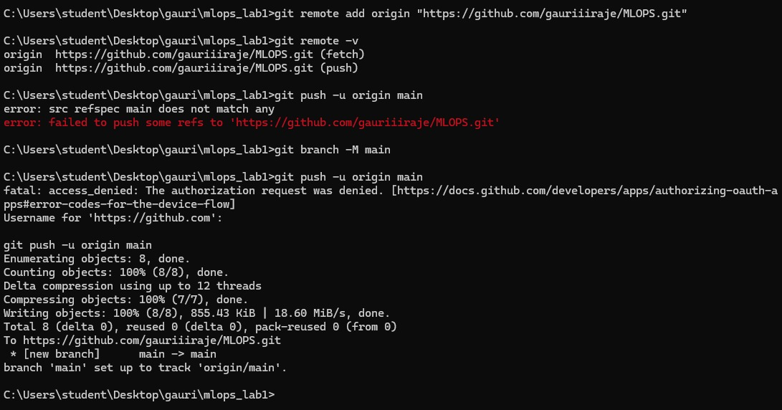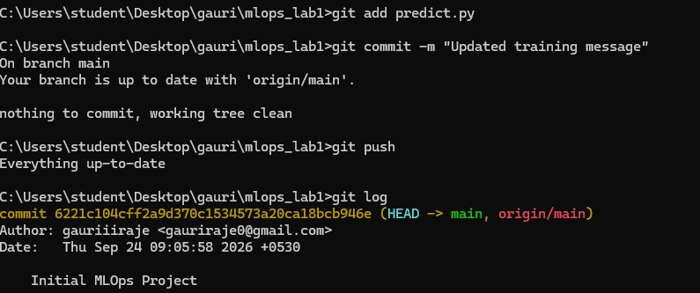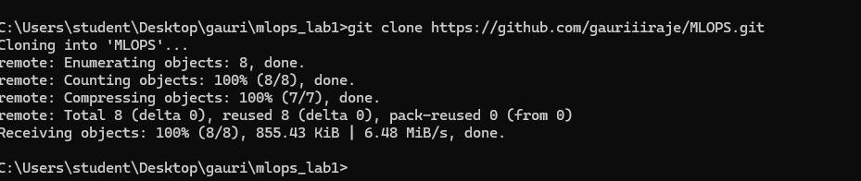

Practical 3 - Load testing on a Machine Learning API that predicts telecom tower hardware failures

Aim :To perform load testing on a Machine Learning API that predicts telecom tower hardware failures and analyze its performance under multiple concurrent users.

Case Study

A telecom company has deployed an AI model that predicts whether a mobile tower is likely to fail.

Thousands of IoT sensors send requests every second.
The company wants to know:
Can the server handle 100 users simultaneously?
What happens if 1,000 users send requests?
Does the response become slow?
Does the server crash?
This is where Load Testing is performed.

Software Required
Python
Flask
JMeter (Apache JMeter)
Trained Random Forest Model (telecom_tower_model.pkl)

Telecom Tower Sensor Data
│
▼
Apache JMeter (100 Users)
Apache JMeter (500 Users)
Apache JMeter (1000 Users)
│
Simultaneous HTTP POST Requests
│
▼
Flask Prediction API
(app.py : Port 5000)
│
▼
Load Trained Random Forest Model
(telecom_tower_model.pkl using joblib)
│
▼
Random Forest Classifier
│
▼
Predict Hardware Failure
│
▼
JSON Response Returned

{"prediction":0} or {"prediction":1}

Step 1 – Install Flask

Open Command Prompt

pip install flask

Step 2 – Create Prediction API

Create

app.py

Write

from flask import Flask, request, jsonify
import pandas as pd
import joblib

app = Flask(__name__)

model = joblib.load("telecom_tower_model.pkl")

@app.route("/")
def home():
return "Telecom Tower Prediction API is Running Successfully!"

@app.route("/predict", methods=["POST"])
def predict():

data = request.get_json()

df = pd.DataFrame([data])

prediction = model.predict(df)

return jsonify({
"prediction": int(prediction[0])
})

app.run(debug=True)

---

Step 4 – Test API

Open browser

http://127.0.0.1:5000
---

Step 5 – Install Apache JMeter

Download Apache JMeter from its official website and extract the ZIP file. Launch jmeter.bat (Windows).

---

Step 6 – Create Test Plan

Open JMeter

Test Plan
↓
Thread Group

---

Configure

Property Value

Number of Users 100
Ramp-Up Period 10 Seconds
Loop Count 5

Meaning

100 users will gradually access the application over 10 seconds.

---
Step 7 – Add HTTP Request

Thread Group
↓
Add
↓
Sampler
↓
HTTP Request

Configure

Field Value

Server localhost
Port 5000
Method GET
Path

---

Step 8 – Add JSON Data

Body

{
"voltage":11.2,
"temperature_c":55,
"signal_drop_rate":0.52,
"cpu_usage":85,
"battery_health":62,
"network_latency_ms":90
}

---

Step 9 – Add Listener

Thread Group
↓
Add
↓
Listener
↓
Summary Report

Also add

View Results Tree

---

Step 10 – Run Load Test

Click

Start

JMeter starts sending requests.

---

Expected Output

You will see

Metric Example

Samples 500
Average Response Time 120 ms
Min 60 ms
Max 240 ms
Throughput 85 Requests/sec
Error % 0%

---

Understanding the Results

Average Response Time

Average time required for one prediction.

Example

120 milliseconds

Lower is better.

Throughput

Number of requests processed every second.

Example

85 Requests/Second

Higher is better.

---

Error %

Shows failed requests.

0%

means all requests succeeded.

---

Maximum Response Time

Highest response time observed.

Example

240 ms

Practical 4 - Linux Basic Commands

pwd — Print Working Directory
Displays the absolute path of the directory you are currently in. Useful for confirming your location before running scripts that use relative paths (a common source of bugs in training pipelines).
ls — List Directory Contents
Lists files and folders in a directory. Common flags: -l (long/detailed format), -a (show hidden files), -h
(human-readable sizes), -t (sort by modification time).
Example:
cd — Change Directory
Moves you into a different directory. cd .. moves up one level, cd ~ or cd alone goes to your home directory, and cd - returns to the previous directory.
find — Search for Files and Directories
Recursively searches a directory tree for files matching a name, type, size, or modification time. Extremely useful for locating stray checkpoint files, logs, or config files in large project directories.
which / whereis — Locate a Command
which shows the full path of the executable that would run for a given command (useful for checking which Python or pip is active in a virtual environment). whereis also shows man pages and source locations.

- File & Directory Management
mkdir — Make Directory
Creates a new directory. Use -p to create nested directories in one command (and to avoid an error if the directory already exists).

touch — Create an Empty File / Update Timestamp
Creates a new empty file if it doesn't exist, or updates its last-modified timestamp if it does. Often used to create placeholder files like init .py or .gitkeep.
cp — Copy Files or Directories
Copies files or directories. Use -r (recursive) for directories and -v for verbose output showing what was copied.
mv — Move or Rename Files
Moves a file/directory to a new location, or renames it if the destination is in the same directory.
rm — Remove Files or Directories
Deletes files. Use -r to delete directories recursively and -f to force deletion without prompts. Because this command is irreversible, it is worth double-checking the path before running it, especially with wildcards.
- Viewing and Editing File Contents
cat — Concatenate and Display File Contents
Prints the entire contents of a file to the terminal. Good for short files like configs or small logs; also used to quickly combine multiple files.
less / more — Page Through a File
Displays file contents one screen at a time, which is far more practical than cat for large log files. Navigate with arrow keys, search with /pattern, and quit with q.
head / tail — View the Start or End of a File
head shows the first lines of a file (default 10), tail shows the last lines. tail -f continuously streams new lines as they are written — ideal for watching a training log in real time.
nano / vim — Terminal Text Editors
Edit files directly in the terminal, which matters on remote servers or containers with no graphical interface. nano is beginner-friendly (on-screen shortcuts); vim is more powerful but has a steeper learning curve.
grep — Search Text Inside Files
Searches for lines matching a pattern. Common flags: -i (case-insensitive), -r (recursive search through a directory), -n (show line numbers).

- File Permissions & Ownership
chmod — Change File Permissions
Controls read (r), write (w), and execute (x) permissions for the owner, group, and others. Permissions can be set numerically (e.g. 755) or symbolically (e.g. u+x). Shell scripts must have execute permission before they can be run directly.
chown — Change File Owner
Changes the user (and optionally group) that owns a file or directory. Commonly needed when files created inside a Docker container end up owned by root on the host.
sudo — Execute as Superuser
Runs a single command with administrator (root) privileges, required for tasks like installing system packages or changing ownership of protected files.

- Process & Job Management
ps — List Running Processes
Displays currently running processes. ps aux shows all processes system-wide with CPU/memory usage — useful for finding a runaway training script.
top / htop — Live Process Monitor
Shows a real-time, continuously updating view of running processes, CPU load, and memory usage.
htop is an enhanced, more readable version (may need to be installed separately). Press q to exit.
kill / kill -9 — Terminate a Process
Sends a signal to stop a process using its Process ID (PID), found via ps. A plain kill requests a graceful shutdown; kill -9 forces immediate termination.
& and nohup — Run Jobs in the Background
Appending & runs a command in the background so the terminal stays free. nohup additionally lets the process keep running after you log out or close the SSH session, writing output to a file.
jobs / fg / bg — Manage Background Jobs
jobs lists background jobs in the current shell, fg brings one to the foreground, and bg resumes a paused job in the background.
- System Monitoring & Resource Usage
df — Disk Free Space
Shows available and used disk space across mounted filesystems. -h gives human-readable sizes (GB/MB), important for checking whether there's room for a new dataset or model checkpoint.
du — Disk Usage
Shows how much space a file or directory is using. du -sh summarizes total size; combine with sort
to find the largest folders.
free — Memory Usage
Displays total, used, and free RAM and swap space. -h shows values in human-readable units. Useful for diagnosing out-of-memory errors during training.
nvidia-smi — GPU Status
Displays GPU utilization, memory usage, temperature, and running processes on NVIDIA GPUs. Essential in MLOps for checking whether a training job is actually using the GPU and how much VRAM is free.
- Networking & Remote Access
ssh — Secure Shell (Remote Login)
Connects to a remote machine (a training server, cloud VM, or container host) over an encrypted connection. Requires the remote host's address and typically a key or password.
scp — Secure Copy Over SSH
Copies files or directories between a local machine and a remote one over SSH. Use -r for directories.
curl / wget — Download Files or Query APIs
curl and wget fetch content from a URL, useful for downloading datasets/model weights or testing a deployed inference API endpoint.
ping — Test Network Connectivity
Checks whether a remote host is reachable and measures round-trip latency. A quick first step when a remote server or API seems unresponsive.

- Archiving, Compression & Transfer
tar — Archive Files
Bundles multiple files/directories into a single archive, commonly combined with compression. -c create,
-x extract, -z gzip compression, -v verbose, -f specify filename.
zip / unzip — Zip Archives
Creates or extracts .zip archives, a widely used cross-platform format for sharing datasets, code, or model artifacts.
rsync — Efficient File Synchronization
Synchronizes files/directories between locations (local or remote over SSH), only transferring the parts that changed. Much faster than scp for large datasets that are updated incrementally.

- Text Processing & Piping
| — Pipe
Sends the output of one command as input to another, allowing small commands to be chained into powerful one-liners for filtering logs, data, or process lists.
- and >> — Redirection
- writes command output to a file, overwriting it; >> appends to the end of a file instead.
wc — Word/Line/Character Count
Counts lines, words, or characters. wc -l is a fast way to check how many rows are in a large CSV file without opening it.

sort / uniq — Sort and Deduplicate Lines
sort orders lines alphabetically or numerically (-n); uniq removes or counts adjacent duplicate lines (often used together, since uniq only works on sorted input).
awk / sed — Pattern-Based Text Processing
awk processes structured text column by column (e.g. extracting a field from a CSV or log line); sed
performs search-and-replace or other line-by-line edits directly from the command line.
- Disk Usage & Storage Housekeeping

df -h and du -sh — Quick Recap
As covered in Section 6, these two commands are the first stop when a job fails due to insufficient disk space: df -h shows free space per filesystem, and du -sh * reveals which folders are the biggest space users.
watch — Repeat a Command Automatically
Reruns a given command at a fixed interval, useful for monitoring disk space, GPU usage, or a log directory while a long job is running.
Example:
- Git Basics for MLOps
git clone / pull / push — Sync with a Remote Repository
clone downloads a repository for the first time; pull fetches and merges the latest changes; push uploads local commits to the remote (e.g. GitHub, GitLab), which typically also triggers CI/CD pipelines in MLOps setups.
git add / commit — Save Changes
git add stages changed files for the next commit; git commit saves a snapshot of the staged changes with a descriptive message, forming the version history of code and configs.
git status / log / diff — Inspect Repository State
status shows changed/staged files, log shows commit history, and diff shows line-by-line differences — all useful for reviewing what changed before committing or deploying.
git branch / checkout — Work with Branches
Branches let you develop or experiment (e.g. a new model architecture) without affecting the main codebase. checkout -b creates and switches to a new branch in one step.
- Useful MLOps-Specific Command Patterns

Running a Training Job in the Background with Logging
Combines backgrounding, output redirection, and process independence so a long training run survives an SSH disconnect and its output is saved for later review.
Watching GPU and Memory Together
Running two monitors side by side (in separate terminal panes or a tmux split) gives a live picture of whether a job is GPU-bound or memory-bound.
tmux / screen — Persistent Terminal Sessions
Creates a terminal session that keeps running on the server even after you disconnect, and lets you reattach later. This is the standard alternative to nohup for long MLOps jobs that need interactive monitoring.
Finding and Cleaning Up Large Checkpoint Files
A common storage-hygiene routine: locate the largest files in a checkpoints directory and remove the ones no longer needed before disk space runs out.
Checking a Service or Container Port
Verifies that a model-serving process (e.g. FastAPI, TorchServe, MLflow) is actually listening on the expected port before debugging further upstream.
Example:
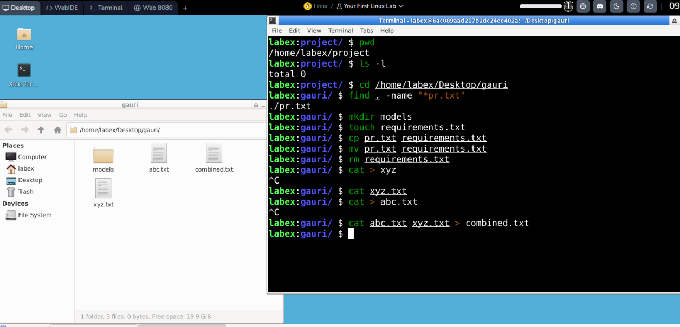
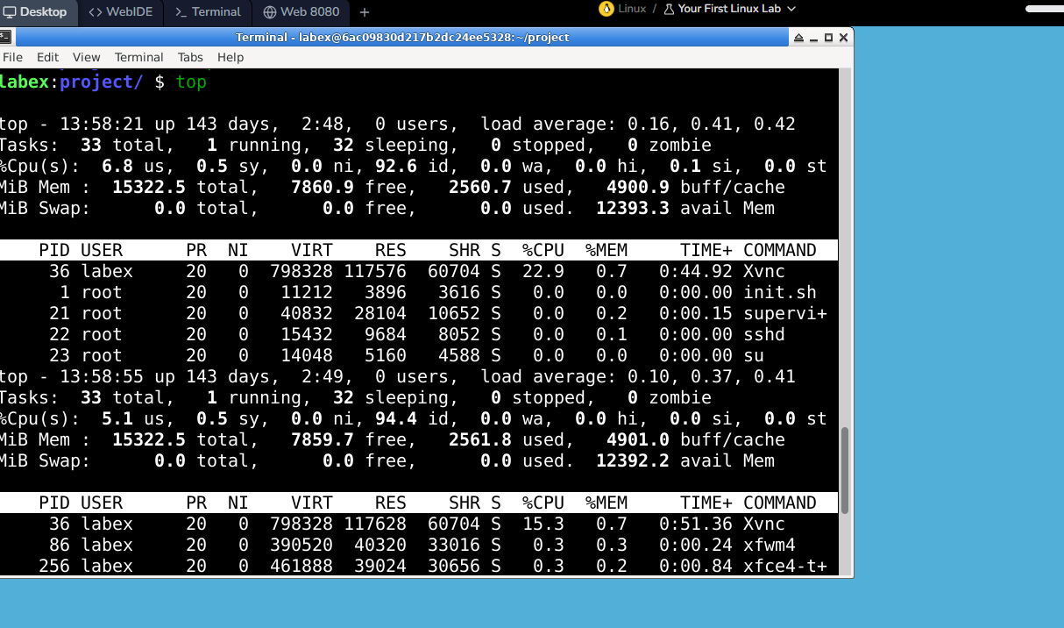

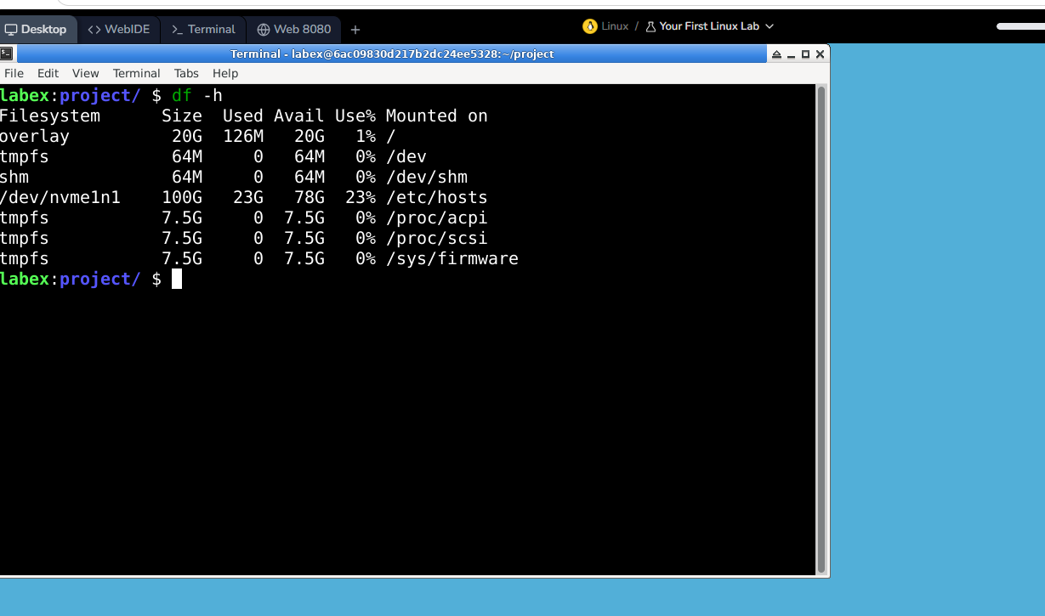

Practical 5 - Monitoring Model Drift Using MLflow and Evidently
Aim :To monitor the performance of a trained machine learning model on new production data and identify model/data drift using MLflow and Evidently.
Theory
In a traditional machine learning project, a model is trained using historical data and then deployed to make predictions on new data. However, the characteristics of real-world data can change over time. As a result, a model that initially performs well may gradually become less accurate. This phenomenon is known as model drift.
Model drift refers to a situation where the performance or behavior of a machine learning model changes after deployment because the real-world environment or incoming data has changed. Drift can occur due to changes in customer behavior, environmental conditions, business processes, sensor readings, or other external factors.
For example, consider a machine learning model developed to predict hardware failures in telecom towers. The model may be trained using historical values of voltage, temperature, and signal drop rate. If environmental conditions change and the new tower data contains significantly higher temperatures and different voltage patterns, the model may no longer make accurate predictions.
Tools Required
- Python / Python IDLE
- Existing telecom_tower_model.pkl
- Existing tower_telemetry.csv
- MLflow
- Evidently
- Pandas
- Scikit-learn

Step 1: Create Practical 5 Folder
C:\Users\sarve\Desktop\MLOPS\mlops prac\prac_5

The folder should initially contain:
prac_5
├── telecom_tower_model.pkl
└── tower_telemetry.xlsx
├── new_tower_telemetry.xlsx

Step 2: Open Command Prompt
Go to your practical folder:
cd "C:\Users\sarve\Desktop\MLOPS\mlops prac\prac_5"

Step 3: Install Required Libraries
Run:
pip install pandas scikit-learn joblib mlflow evidently

Step 5 — Check Your Old Model
Before we write the monitoring program, we need to make sure your .pkl model was trained using the same 8 features in your dataset.
Your model should have been trained with:
Temperature_C
Battery_Voltage
Power_Consumption_W
Signal_Strength_Percent
Fan_Speed_RPM
Humidity_Percent
Traffic_Load
Tower_Age_Years

and the target:
Failure_Within_48Hrs

Step 6 — Create monitor_model.py
Open Python IDLE.
Click:
File → New File
Save it as:
Monitor_model.py

Step 7 — Paste This Code
Paste the following into monitor_model.py:

import pandas as pd
import joblib
import mlflow
from sklearn.metrics import accuracy_score
# ---------------------------------------
# 1. Load the trained Random Forest model
# ---------------------------------------

model = joblib.load("telecom_tower_model.pkl")
print("Model loaded successfully!")
# ---------------------------------------
# 2. Load NEW production data
# ---------------------------------------
new_data = pd.read_excel("new_tower_telemetry.xlsx")
print("New production data loaded successfully!")
# ---------------------------------------
# 3. Select ML features
# ---------------------------------------
features = [
"Temperature_C",
"Battery_Voltage",
"Power_Consumption_W",
"Signal_Strength_Percent",
"Fan_Speed_RPM",
"Humidity_Percent",
"Traffic_Load",
"Tower_Age_Years"
]
X_new = new_data[features]

y_new = new_data["Failure_Within_48Hrs"]
# ---------------------------------------
# 4. Make predictions
# ---------------------------------------
predictions = model.predict(X_new)
# ---------------------------------------
# 5. Calculate accuracy
# ---------------------------------------
accuracy = accuracy_score(
y_new,
predictions
)
print("-----------------------------------")
print("MODEL DRIFT MONITORING")
print("-----------------------------------")
print(
"Production Accuracy:",
round(accuracy, 2)
)
# ---------------------------------------

# 6. Start MLflow experiment
# ---------------------------------------
mlflow.set_experiment(
"Telecom_Tower_Model_Monitoring"
)
with mlflow.start_run():
mlflow.log_param(
"model",
"Random Forest"
)
mlflow.log_param(
"n_estimators",
100
)
mlflow.log_metric(
"production_accuracy",
accuracy
)
print("Results logged successfully to MLflow")

# ---------------------------------------
# 7. Drift / performance threshold
# ---------------------------------------
threshold = 0.80
if accuracy < threshold:
print()
print("WARNING: Model performance has degraded!")
print("Model retraining is recommended.")
else:
print()
print("Model performance is stable.")

Step 8 — Run the Program

Expected output
If everything is correct, you should see:
Model loaded successfully!
New production data loaded successfully!

-----------------------------------
MODEL DRIFT MONITORING
-----------------------------------

Production Accuracy: 0.xx

Results logged successfully to MLflow

WARNING: Model performance has degraded!
Model retraining is recommended.

Step 9 — Start MLflow
Now open a second Command Prompt window.
Run:
cd "C:\Users\sarve\Desktop\MLOPS\mlops prac\prac_5"
Then:
mlflow ui

You should see something similar to:
Listening at: http://127.0.0.1:5000

Step 10 — Open MLflow
Open Chrome and enter:
http://127.0.0.1:5000

You should see the MLflow dashboard.
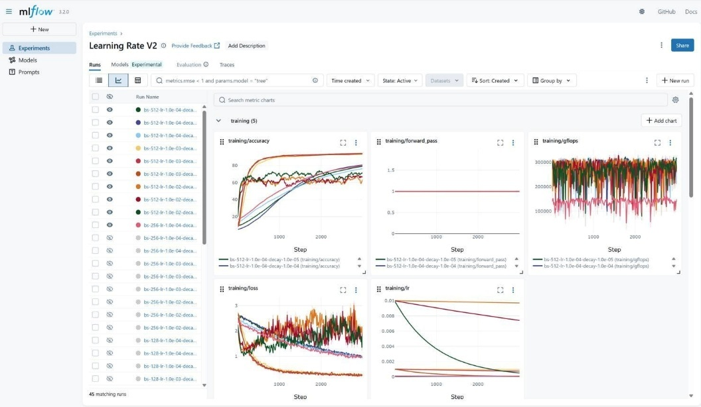

Look for:
Telecom_Tower_Model_Monitoring
Click it.
You should see your experiment/run.

Step 11 — Check the MLflow Metrics
Inside the run, you should find:
Parameters
model = Random Forest

n_estimators = 100
Metric
production_accuracy = 0.xx
This demonstrates that MLflow is tracking the model's production performance.

Practical 6 - Configuring the CI/CD Pipeline for Telecom Tower Failure Prediction using AWS CodePipeline

Step 1 – Create a GitHub Repository
Objective: Store the Machine Learning project in a central repository so AWS can access the latest code.
Procedure
- Open GitHub and log in.
- Click New Repository.
- Repository Name:
Telecom-MLOps
- Upload the following files:
telecom_tower_failure.csv
train.py
requirements.txt
buildspec.yml
README.md
- Click Commit Changes.
Step 2 – Create an Amazon S3 Bucket
Objective: Store the trained Machine Learning model (model.pkl) in cloud storage.
Procedure
- Login to AWS Console.
- Search for Amazon S3.
- Click Create Bucket.
- Bucket Name:
telecom-mlops-model-storage
- Leave all settings as default.
- Click Create Bucket.

Step 3 – Create an IAM Role
Objective: Give AWS CodeBuild permission to access Amazon S3.
Procedure
- Open IAM.
- Click Roles.
- Click Create Role.
- Select:
  - Trusted Entity: AWS Service
  - Use Case: CodeBuild
- Attach the following policies:
  - AmazonS3FullAccess
  - AWSCodeBuildDeveloperAccess
  - CloudWatchLogsFullAccess
- Role Name:
CodeBuildTelecomRole
- Click Create Role.

Step 4 – Create the
buildspec.yml
File
Objective: Tell AWS exactly how to build and train the model.
Procedure
Create a file named:
buildspec.yml
Paste the following code:
version: 0.2

phases:
install:
runtime-versions:
python: 3.11

commands:
- pip install -r requirements.txt

build:
commands:
- python train.py

artifacts:
files:
- model.pkl
Save the file and push it to GitHub.
“buildspec.yml is like an instruction manual for AWS. It tells AWS which libraries to install, which Python file to execute, and which output file (model.pkl) should be saved.”

Step 5 – Create an AWS CodeBuild Project
Objective: Configure AWS to automatically train the Random Forest model.
Procedure
- Open AWS CodeBuild.
- Click Create Build Project.
Project Name:
TelecomModelTraining
- Source Provider:
GitHub
- Connect your Telecom-MLOps repository.
- Environment:
  - Operating System: Ubuntu
  - Runtime: Managed Image
  - Language: Python
- Service Role:
CodeBuildTelecomRole
- Build Specification:
Use buildspec.yml
- Click Create Build Project.

Step 6 – Test the Build Process
Objective: Verify that AWS can successfully train the model.
Procedure
- Open the CodeBuild Project.
- Click Start Build.
AWS performs the following steps automatically:
Download Source Code
↓
Install Python Libraries
↓
Read telecom_tower_failure.csv
↓
Train Random Forest Model
↓
Generate model.pkl
↓
Build Successful
- Open Build History → Latest Build → View Logs.

Step 7 – Create an AWS CodePipeline
Objective: Automate the complete Machine Learning workflow.
Procedure
- Open AWS CodePipeline.
- Click Create Pipeline.
Pipeline Name:
TelecomMLOpsPipeline
- Source Stage:
  - Provider: GitHub Version 2
  - Repository: Telecom-MLOps
  - Branch: main
- Build Stage:
  - Provider: AWS CodeBuild
  - Project: TelecomModelTraining
- Deployment Stage:
  - Skip Deployment
- Click Create Pipeline.

Step 8 – Trigger Automatic Training
Objective: Verify that the pipeline automatically retrains the model.
Procedure
Open train.py.
Change:
n_estimators = 100
to
n_estimators = 150
Save the file.
Commit the changes.
Push the updated code to GitHub.

Step 9 – Observe Automatic Pipeline Execution
After pushing the code, AWS automatically starts the pipeline.
The execution flow is:
Developer Updates train.py
↓
Push to GitHub
↓
AWS CodePipeline Detects Change
↓
AWS CodeBuild Starts
↓
Install Libraries
↓
Execute train.py
↓
Train Random Forest Model
↓
Generate model.pkl
↓
Upload model.pkl to Amazon S3

Step 10 – Verify the Output
- Open Amazon S3.
- Open the bucket:
telecom-mlops-model-storage
- Verify that the latest model.pkl file is present.

Expected Output
- The updated code is pushed to GitHub.
- AWS CodePipeline automatically detects the change.
- AWS CodeBuild retrains the Random Forest model.
- A new model.pkl file is generated.
- The trained model is uploaded to Amazon S3.
- The entire process is completed without any manual retraining.

Practical 7 - Create an Amazon S3 Bucket
Aim :To create an Amazon S3 bucket for storing datasets and trained machine learning models.

What is Amazon S3?
Amazon S3 (Simple Storage Service) is a cloud storage service provided by AWS.
Instead of storing files on your local computer, organizations store datasets, trained models, reports, logs, and backups securely in Amazon S3.
Real-World Example
Think of Amazon S3 as Google Drive for an organization.
Instead of:
C:\Users\Sarvesh\Desktop\MLOPS
we store the files in Amazon S3 where everyone in the organization can access them (subject to permissions).

Architecture
Local Computer
│
▼
tower_telemetry.csv
telecom_tower_model.pkl
│
▼
Amazon S3 Bucket

Step 9.1 – Login to AWS Console
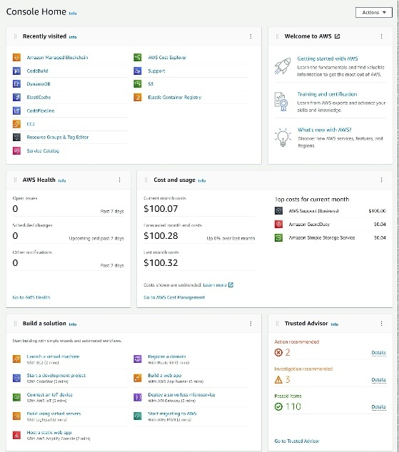
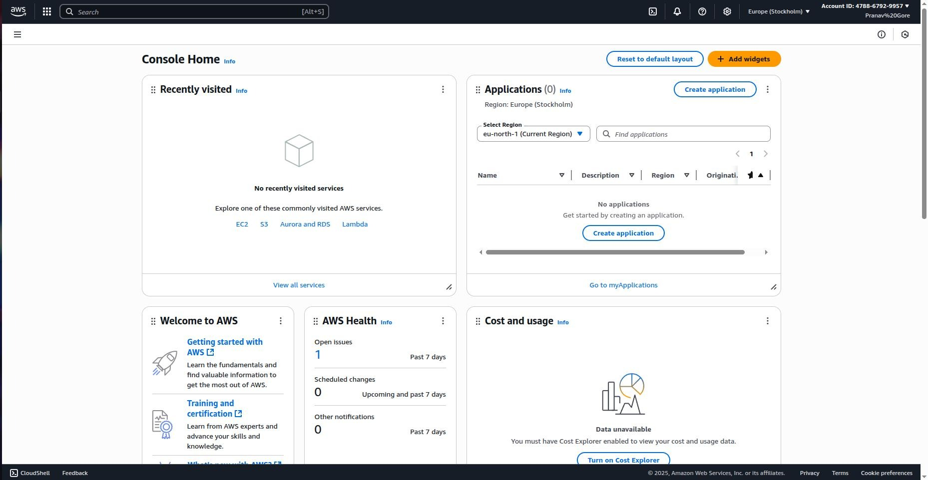
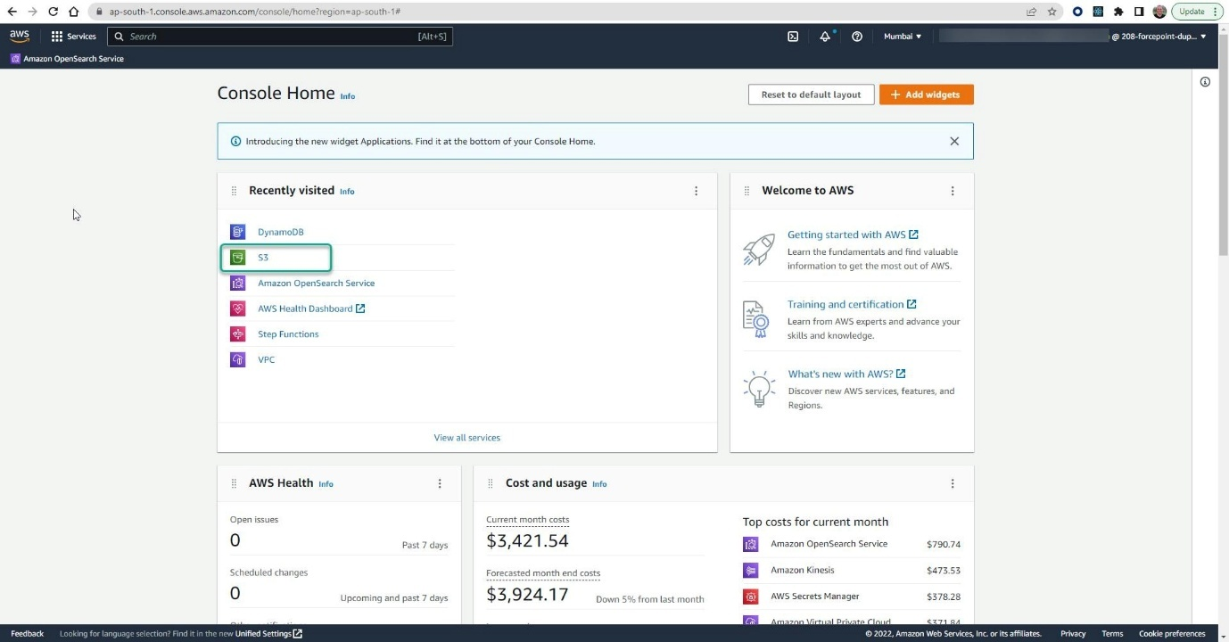
- Open your web browser.
- Go to:
https://console.aws.amazon.com/

- Login using your IAM User.

Step 9.2 – Search for Amazon S3
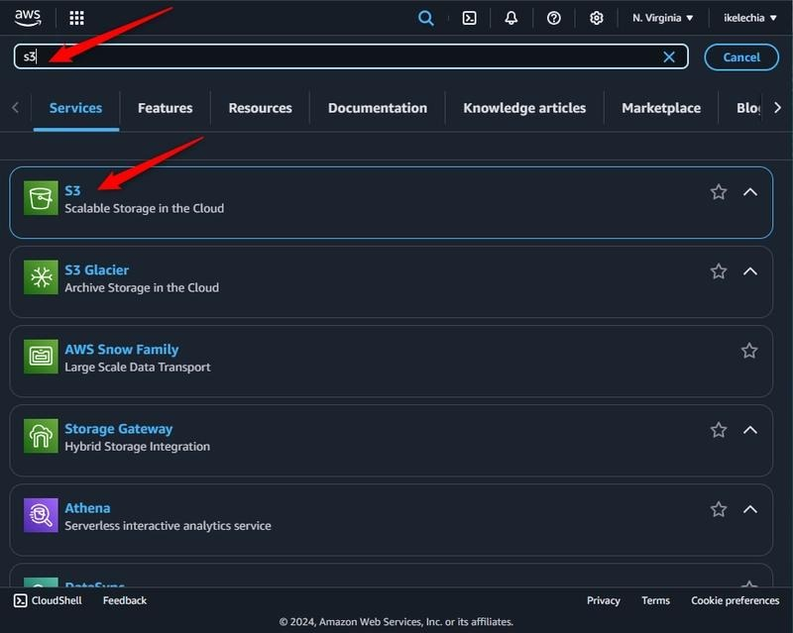
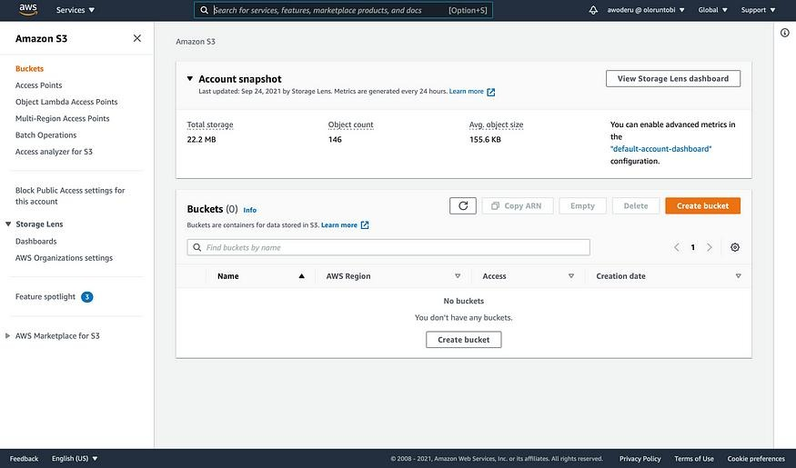
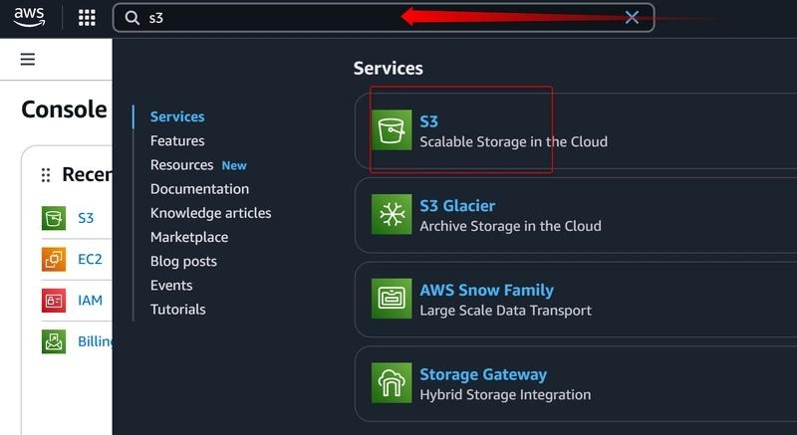
- In the AWS Search Bar type
S3

- Click
Amazon S3

Step 9.3 – Create Bucket
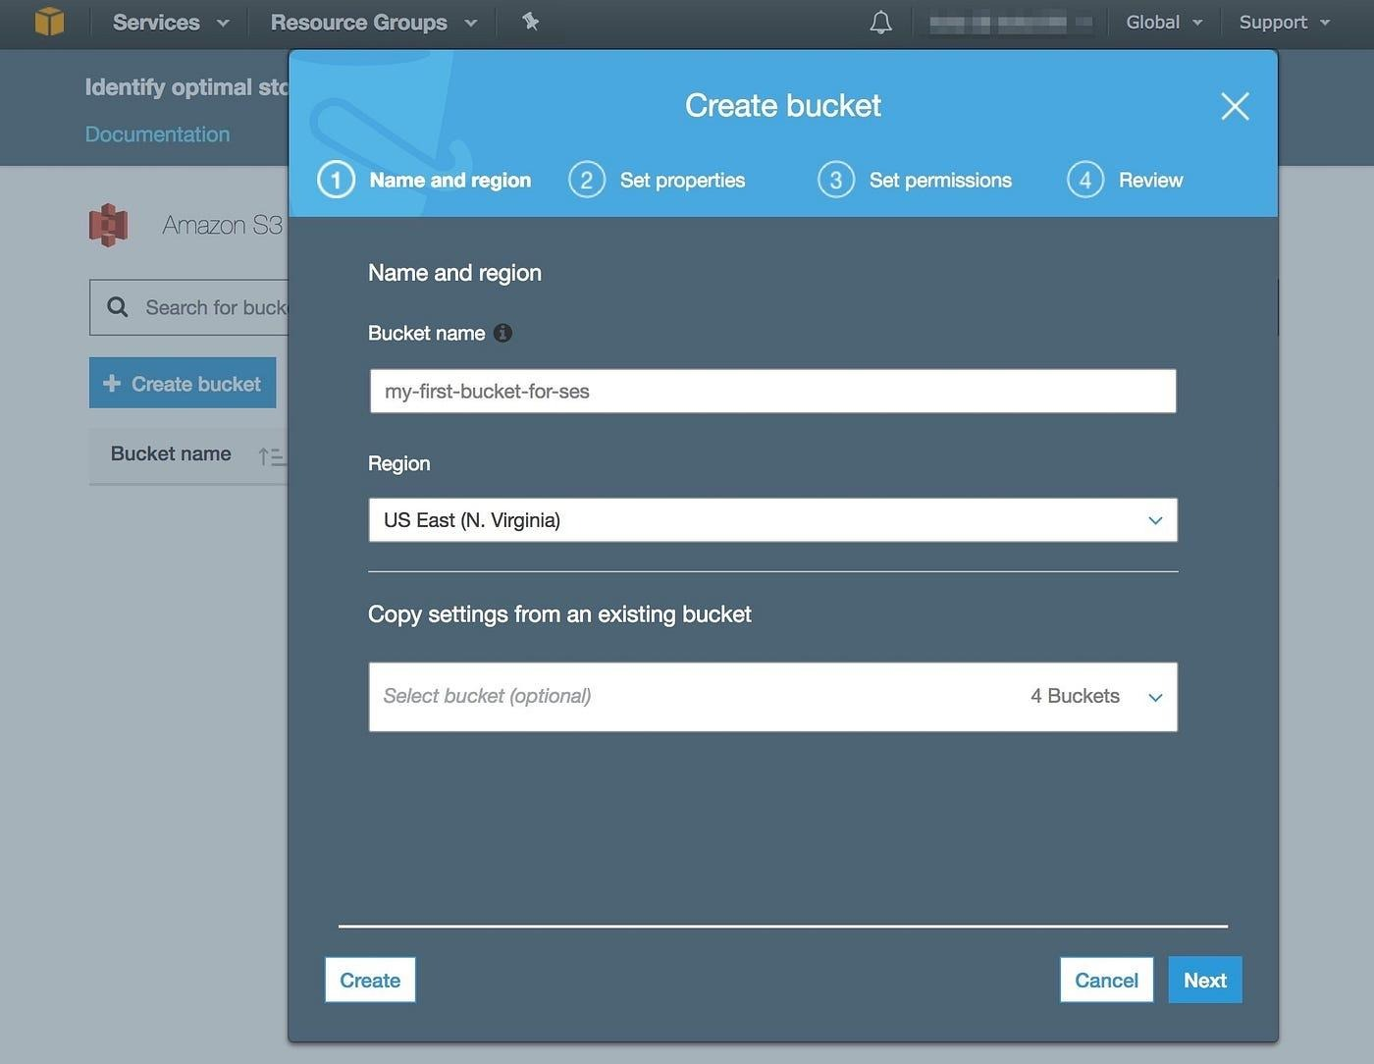
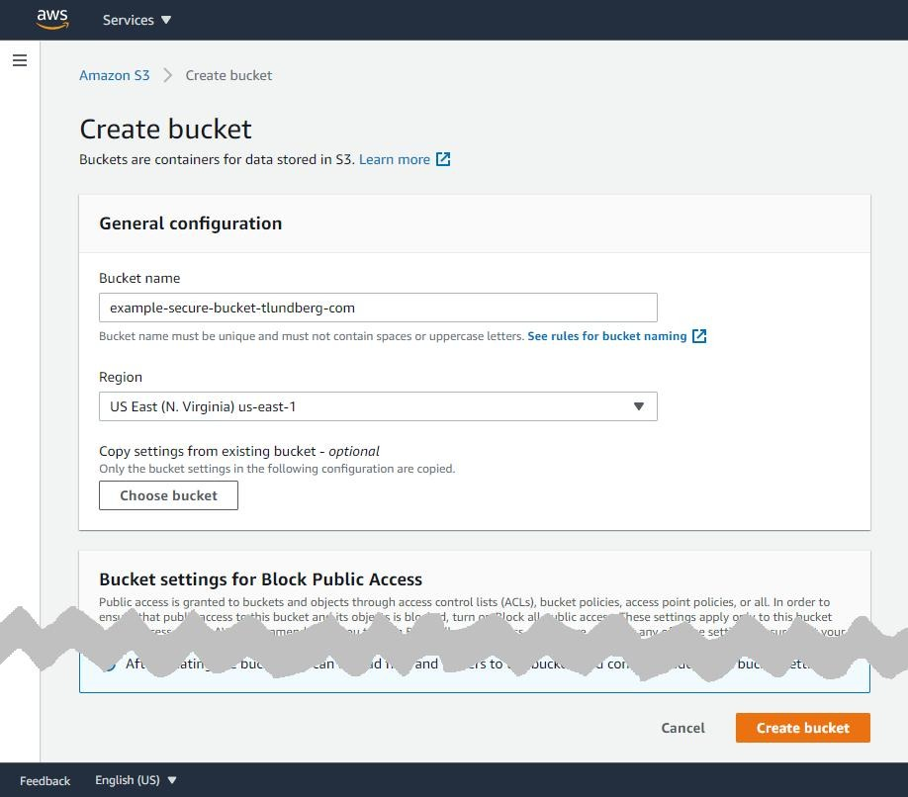
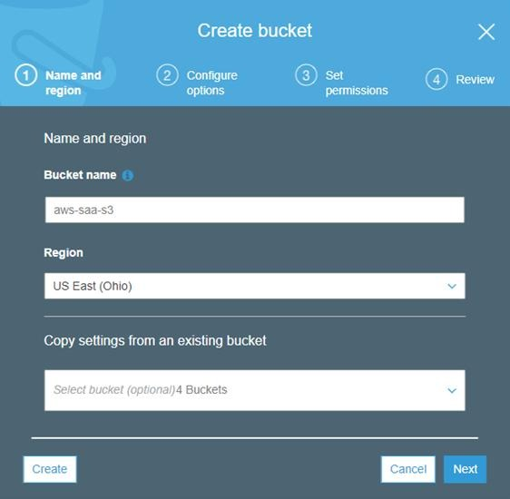
Click
Create Bucket

Step 9.4 – Enter Bucket Details
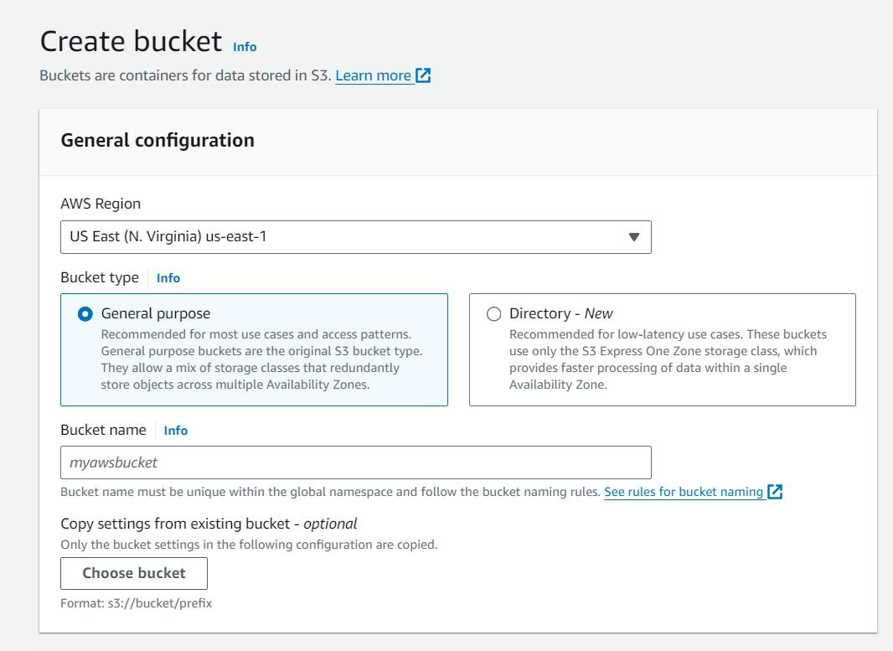
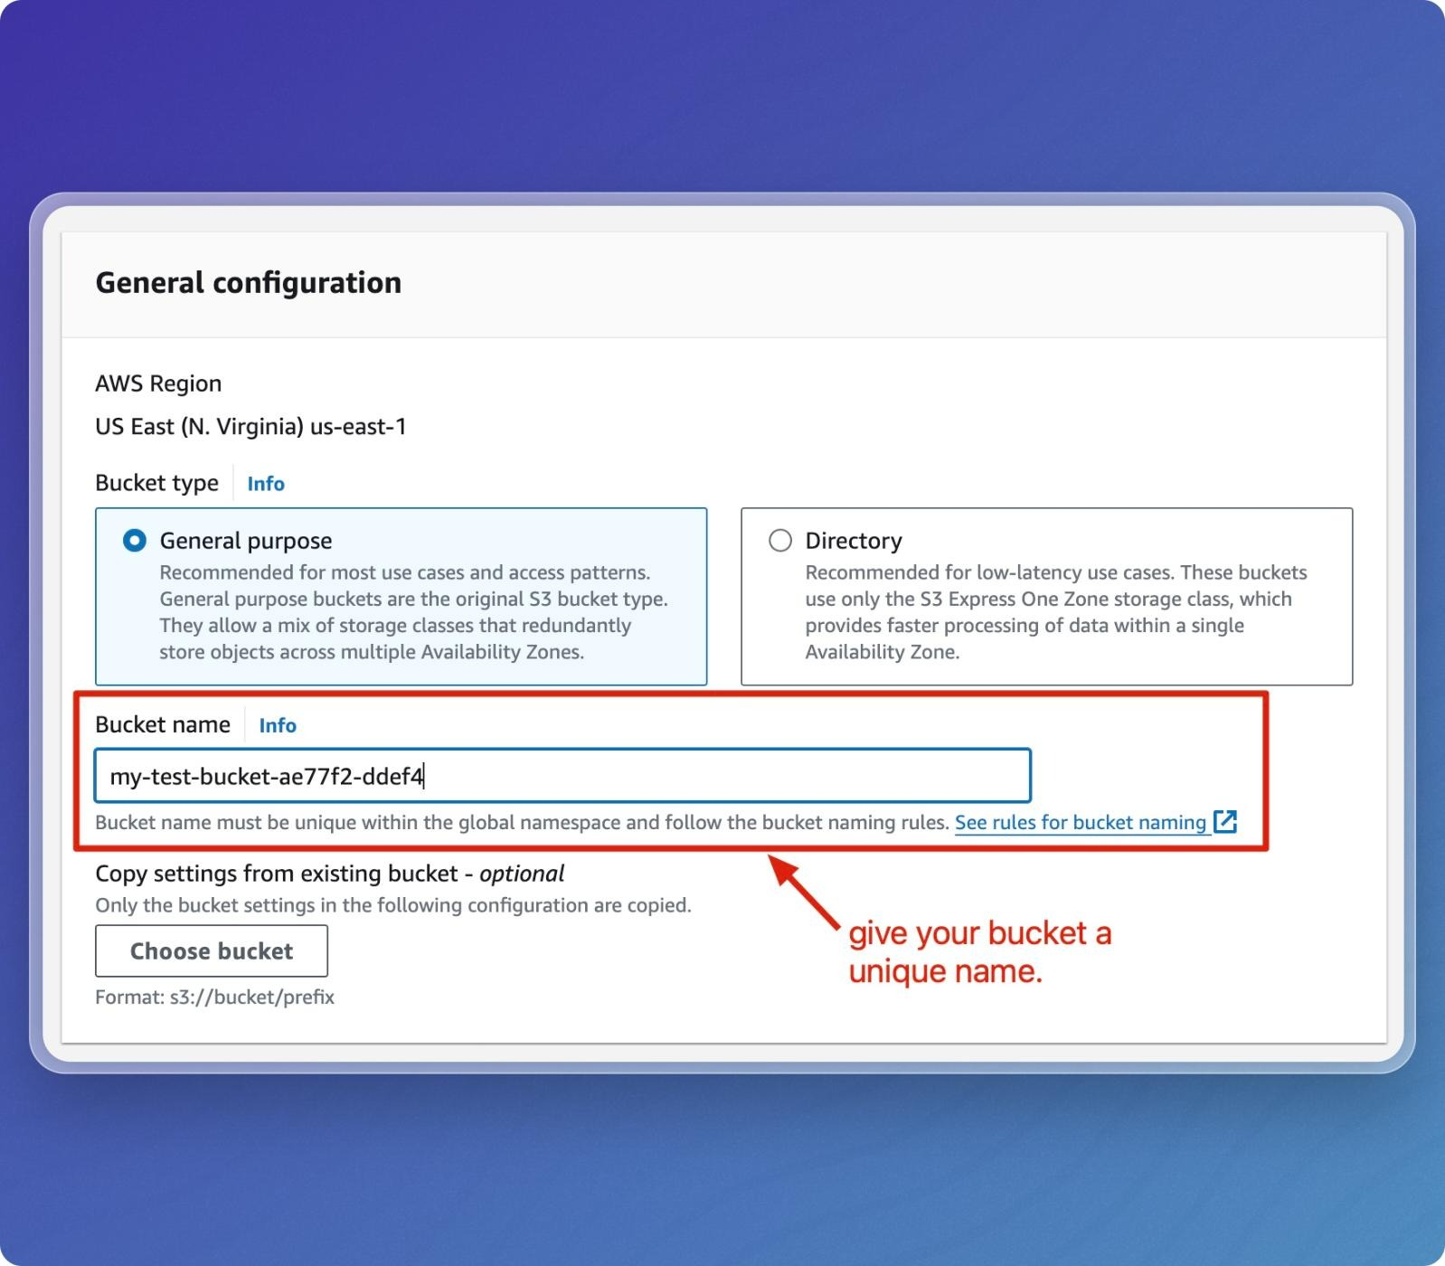
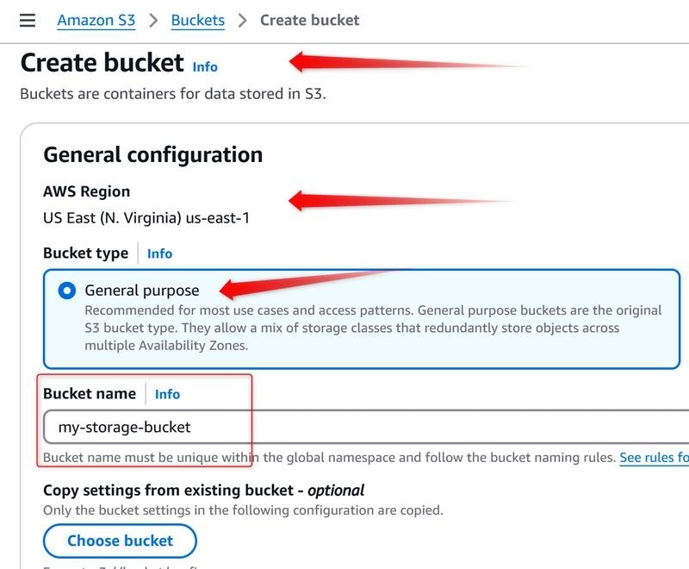
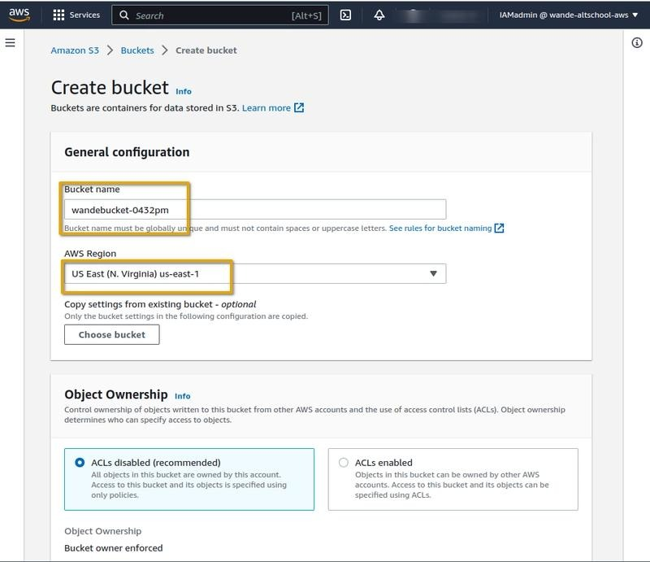
Enter
Field | Value
Bucket Name | telecom-mlops-bucket-yourname
AWS Region | us-east-1 (or your preferred region)
Example
telecom-mlops-bucket-sarvesh

Note: Bucket names must be globally unique. If the name is already taken, add your initials or roll number.

Step 9.5 – Keep Default Settings
Leave all settings as default.
Do NOT change:
- Bucket Versioning
- Default Encryption
- Object Ownership
- Lifecycle Rules
Scroll down.
Click
Create Bucket

Expected Output
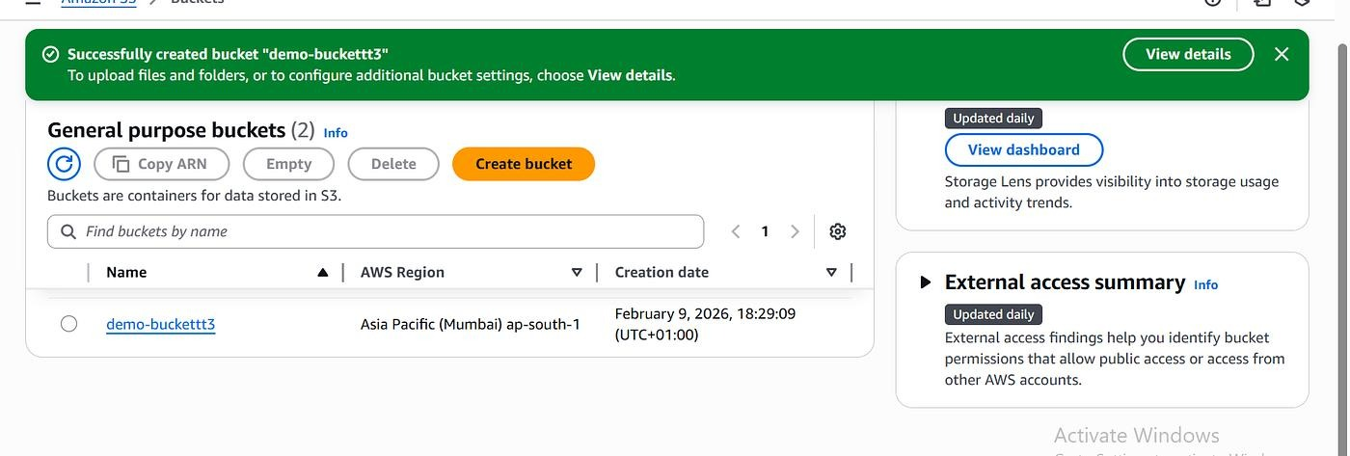
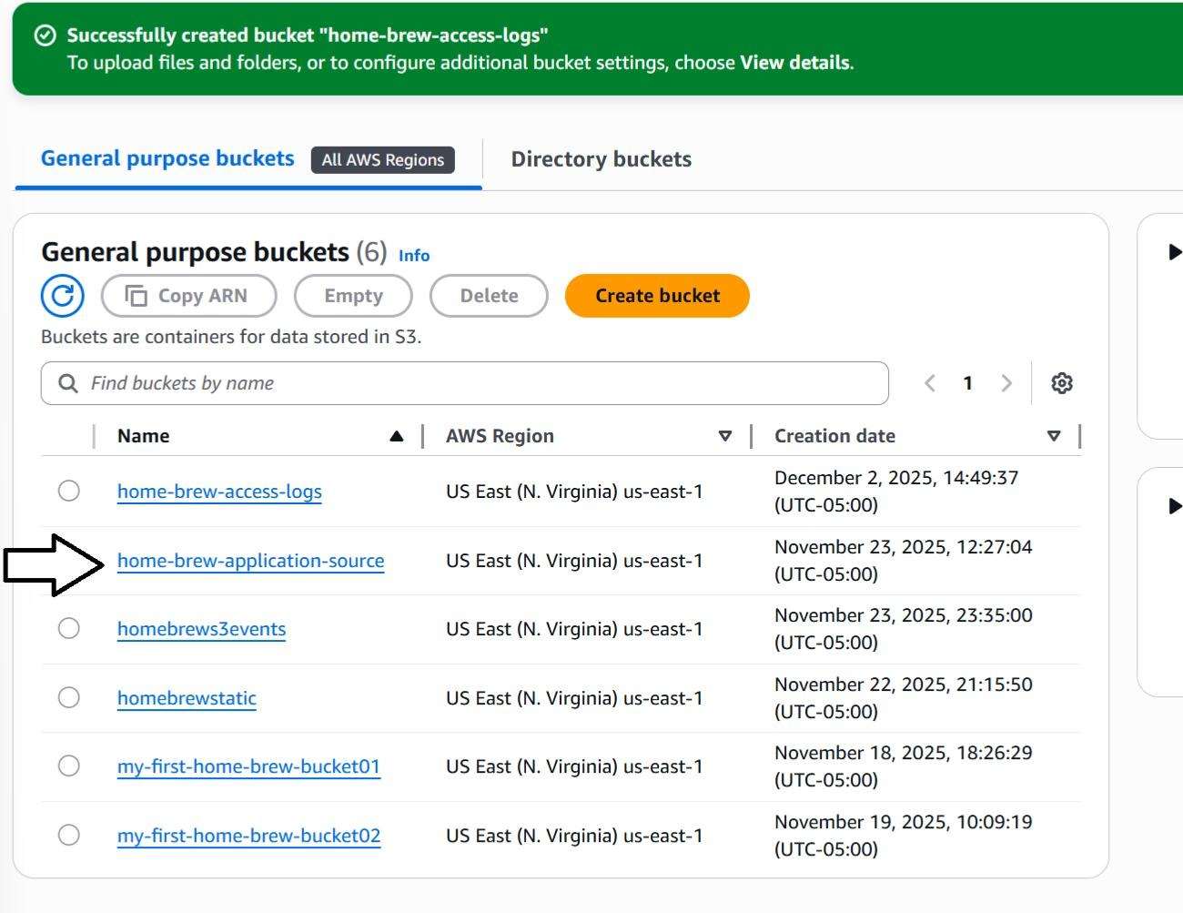
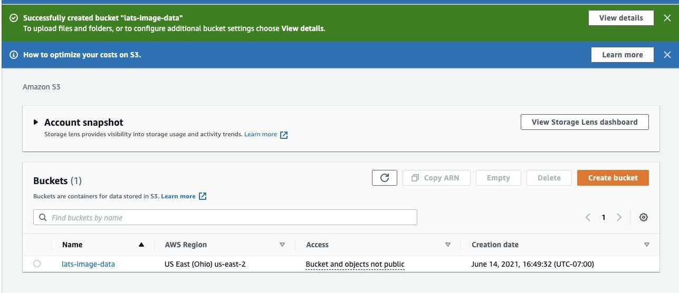
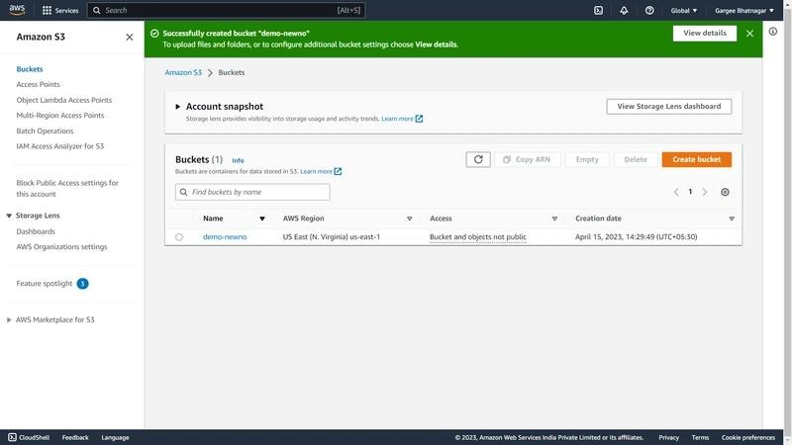
The bucket appears in the S3 Bucket List.
Example
telecom-mlops-bucket-sarvesh

Step 10 – Upload Dataset
Open your bucket.
Click
Upload

Upload Screen
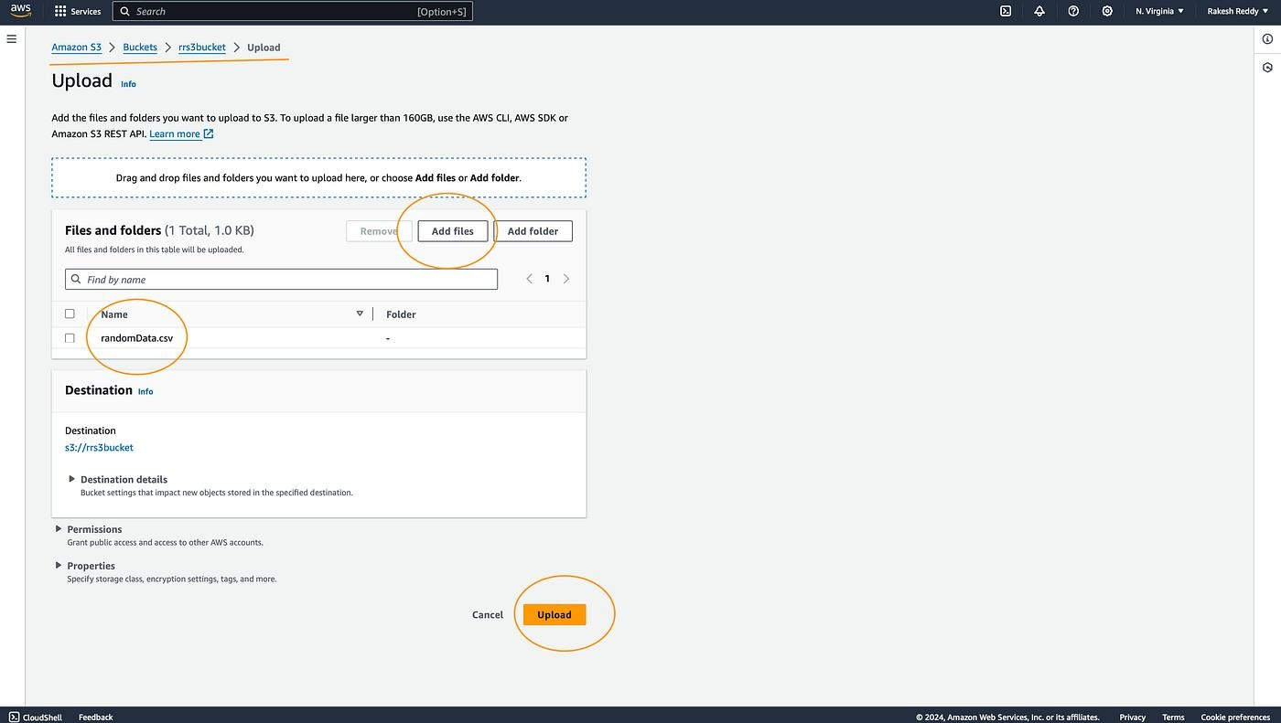
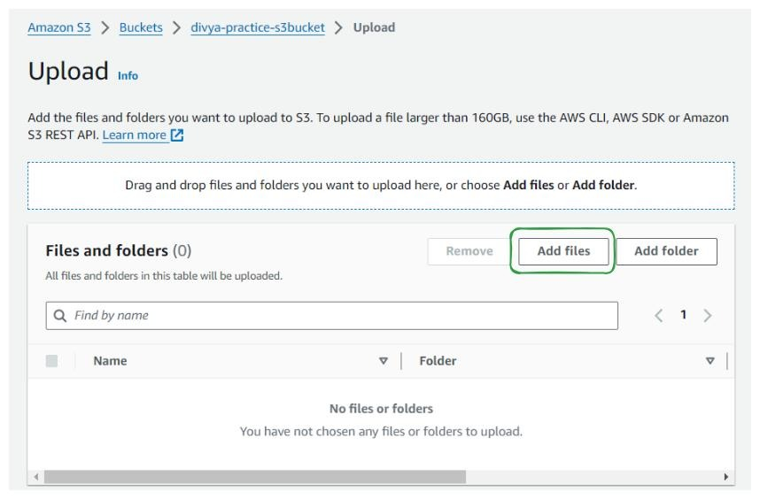
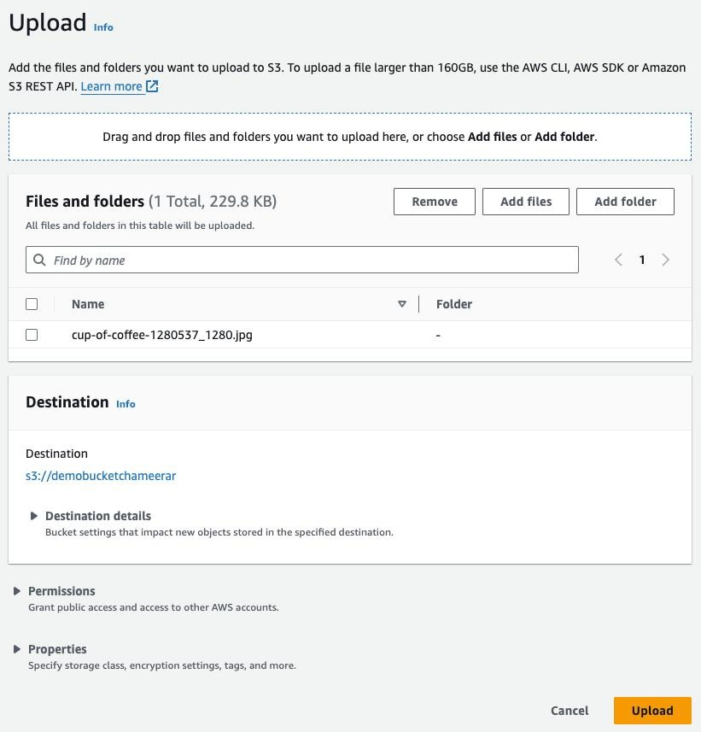
Click
Add Files
Select
tower_telemetry.csv

Click
Upload

Expected Output
The uploaded dataset should appear inside the bucket.
tower_telemetry.csv

Step 11 – Upload Machine Learning Model
Again click
Upload
Choose
telecom_tower_model.pkl

Click
Upload

Expected Output
Your bucket now contains
tower_telemetry.csv

telecom_tower_model.pkl

Step 12 – Create Folder Structure
Inside the bucket click
Create Folder
Create
data

Create another folder
models

Your bucket should look like
telecom-mlops-bucket-sarvesh

│

├── data

│ └── tower_telemetry.csv

│

└── models

└── telecom_tower_model.pkl

Folder Structure Example
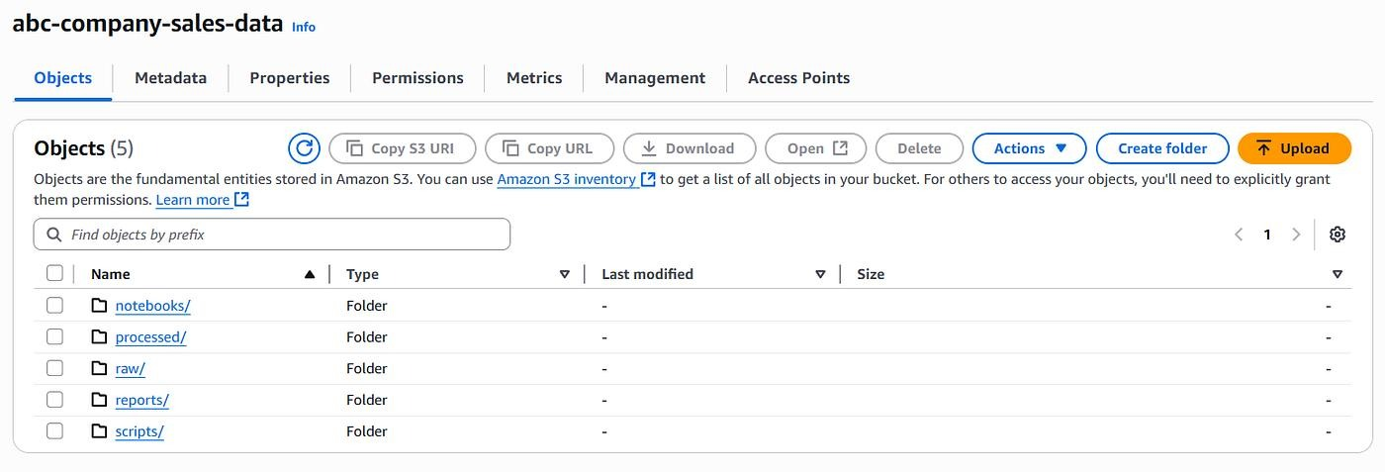
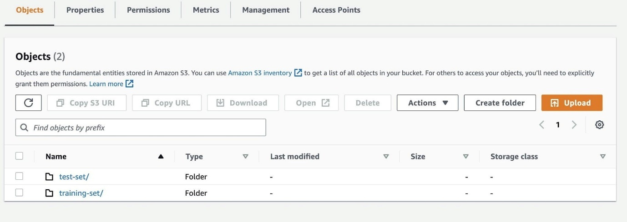
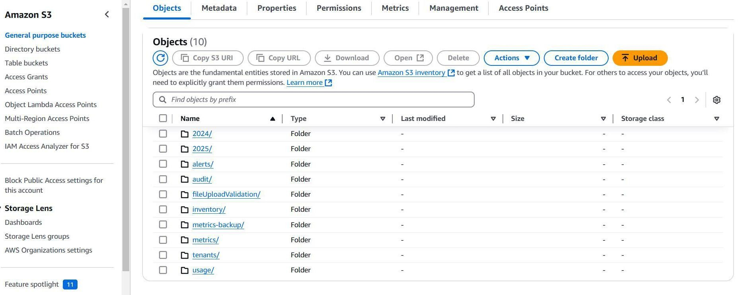

Why Create Separate Folders?
Folder | Purpose
data | Stores datasets
models | Stores trained ML models
logs (later) | Stores build logs
metrics (later) | Stores evaluation reports
This organization makes the bucket easier to manage as the project grows.

Step 13 – Verify Upload
Open
data

Verify
tower_telemetry.csv

Now open
models

Verify
telecom_tower_model.pkl

Both files should be visible.

Step 14 – Understanding the MLOps Workflow
Local Computer

│

▼

tower_telemetry.csv

telecom_tower_model.pkl

│

▼

Amazon S3

│

▼

AWS CodeBuild

│

▼

Model Training

│

▼

Upload Updated Model

│

▼

Amazon S3

Practical 8: Create a Serverless Workflow

Aim:To create and execute a serverless workflow using Google Cloud Workflows without managing any physical or virtual servers.

1. What is Serverless Computing?
Serverless computing is a cloud computing model in which the cloud provider manages the servers, operating system, infrastructure, scaling, and availability.
The developer only needs to provide the application code or workflow definition.
> Important: Serverless does not mean that there are no servers. Servers are still used, but their management is handled by the cloud provider.

2. What is a Serverless Workflow?
A serverless workflow is a sequence of tasks that are executed automatically in a predefined order using a cloud service.

For example:

Start
↓
Task 1: Receive Request
↓
Task 2: Process Data
↓
Task 3: Generate Result
↓
Task 4: Return Response
↓
End

Google Cloud Workflows can be used to coordinate multiple services and execute them in a defined sequence.

3. Requirements

1. Google Account

2. Google Cloud Console

3. Internet connection

4. Google Cloud project

5. Google Cloud Workflows service

Procedure / Steps

Step 1: Open Google Cloud Console

Sign in using your Google account.

You will see the Google Cloud Console dashboard.

Journal Screenshot 1: Take a screenshot of the Google Cloud Console dashboard.

Step 2: Create a Google Cloud Project

1. Click the Project Selector at the top of the page.

2. Select New Project.

3. Enter a project name.

Example:

Serverless-Workflow-Practical

4. Click Create.

5. Select the newly created project.

Journal Screenshot 2: Project creation screen.

Step 3: Enable Workflows

From the Google Cloud Console:

1. Open the navigation menu.

2. Select Workflows.

3. If prompted, enable the required API.

The Workflows service allows us to define and execute a sequence of cloud tasks.

Journal Screenshot 3: Google Cloud Workflows page.

Step 4: Create a Workflow

Click:

Create Workflow

Enter:

Workflow Name: my-serverless-workflow
Region: Select any available region

For example:

my-serverless-workflow

Step 5: Define the Workflow

In the workflow editor, enter the following YAML:

main:
steps:
- start:
call: sys.log
args:
text: "Serverless Workflow Started"

- process:
assign:
- message: "Hello from Google Cloud Workflows"

- display:
call: sys.log
args:
text: ${message}

- finish:
return: ${message}

What does this code do?

The workflow contains four steps:

start
↓
process
↓
display
↓
finish

start
Displays a message indicating that the workflow has started.

process
Creates a variable called message.

display
Displays the value of the variable in the workflow logs.

finish
Returns the final message.

Step 6: Save the Workflow

Click Deploy or Create, depending on the interface displayed.

Google Cloud validates the workflow definition.

If there are no errors, the workflow is created successfully.

Journal Screenshot 4: Workflow YAML editor showing the code.

Step 7: Execute the Workflow

After creating the workflow:

1. Open the workflow.

2. Click Execute.

3. Keep the input empty because our workflow does not require input.

4. Click Execute.

The workflow will execute the steps sequentially.

Start
↓
Process
↓
Display
↓
Return Result

Journal Screenshot 5: Execute Workflow screen.

Step 8: Check the Execution Result

After execution, Google Cloud displays the execution details.

The returned result should be similar to:

Hello from Google Cloud Workflows

Journal Screenshot 6: Successful execution/result screen.

---

Result

The serverless workflow was successfully created and executed using Google Cloud Workflows without manually creating or managing a server.

Observation

Step Operation Output

1 Start workflow Workflow Started
2 Create message Message created
3 Display message Message displayed in logs
4 Return result Hello from Google Cloud Workflows

Conclusion

A serverless workflow was successfully implemented using Google Cloud Workflows. The practical demonstrated how multiple operations can be arranged into a sequence and executed automatically without managing the underlying server infrastructure.

Viva Questions

1. What is serverless computing?
Serverless computing is a cloud model where the cloud provider manages the underlying servers and infrastructure.

2. Does serverless mean there are no servers?
No. Servers are still used, but their management is handled by the cloud provider.

3. What is Google Cloud Workflows?
It is a service used to define and execute a sequence of tasks and coordinate different Google Cloud services.

4. What language is commonly used to define a Google Cloud Workflow?
YAML.

5. What is the advantage of serverless architecture?
It reduces infrastructure management and allows applications to scale automatically according to demand.

6. Give examples of serverless services.
Google Cloud Workflows, Cloud Functions, and Cloud Run are examples of services that can be used in serverless architectures.

